**MongoDB Assignment-1**

**Shahuraj Bhoite 258077  
  
show dbs**

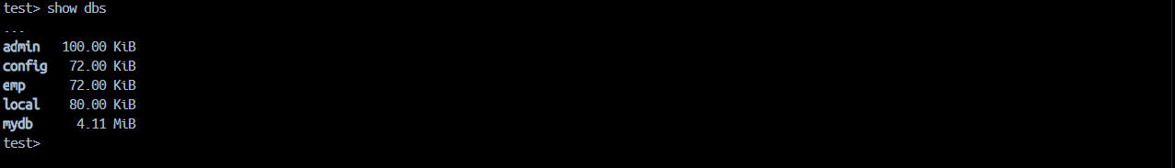

**use mydb**

**show collections**

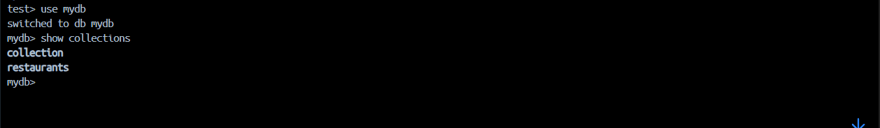

**1. Write a MongoDB query to display all the documents in the collection restaurants**

**db.restaurants.find()**

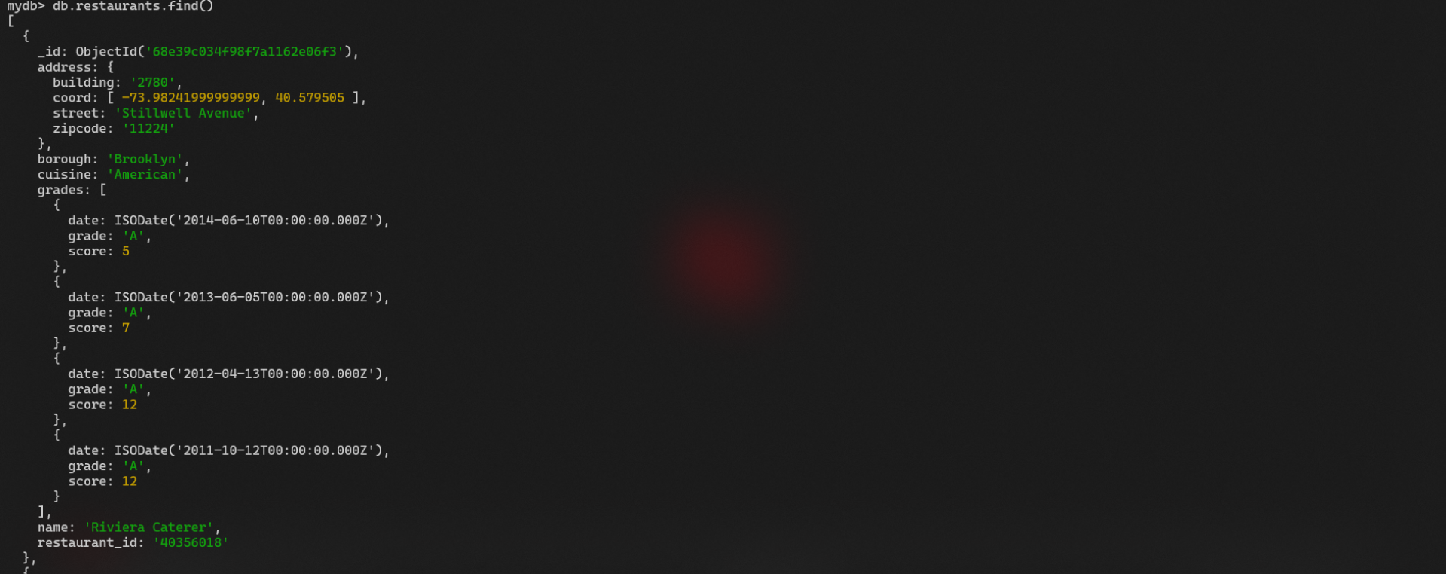

**2. Write a MongoDB query to display the fields restaurant_id, name, borough and cuisine for all the documents in the collection restaurant.**

**db.restaurants.find({},**

**{restaurant_id:1, name:1, borough:1, cuisine:1}**

**)**

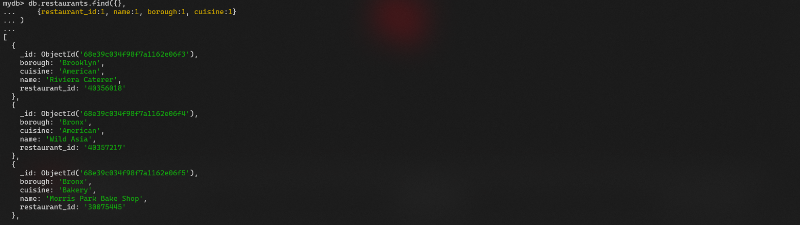

**3. Write a MongoDB query to display the fields restaurant_id, name, borough and cuisine, but exclude the field _id for all the documents in the collection restaurant.**

**db.restaurants.find({},**

**{_id: 0, restaurant_id: 1, name: 1, borough: 1, cuisine: 1}**

**)** 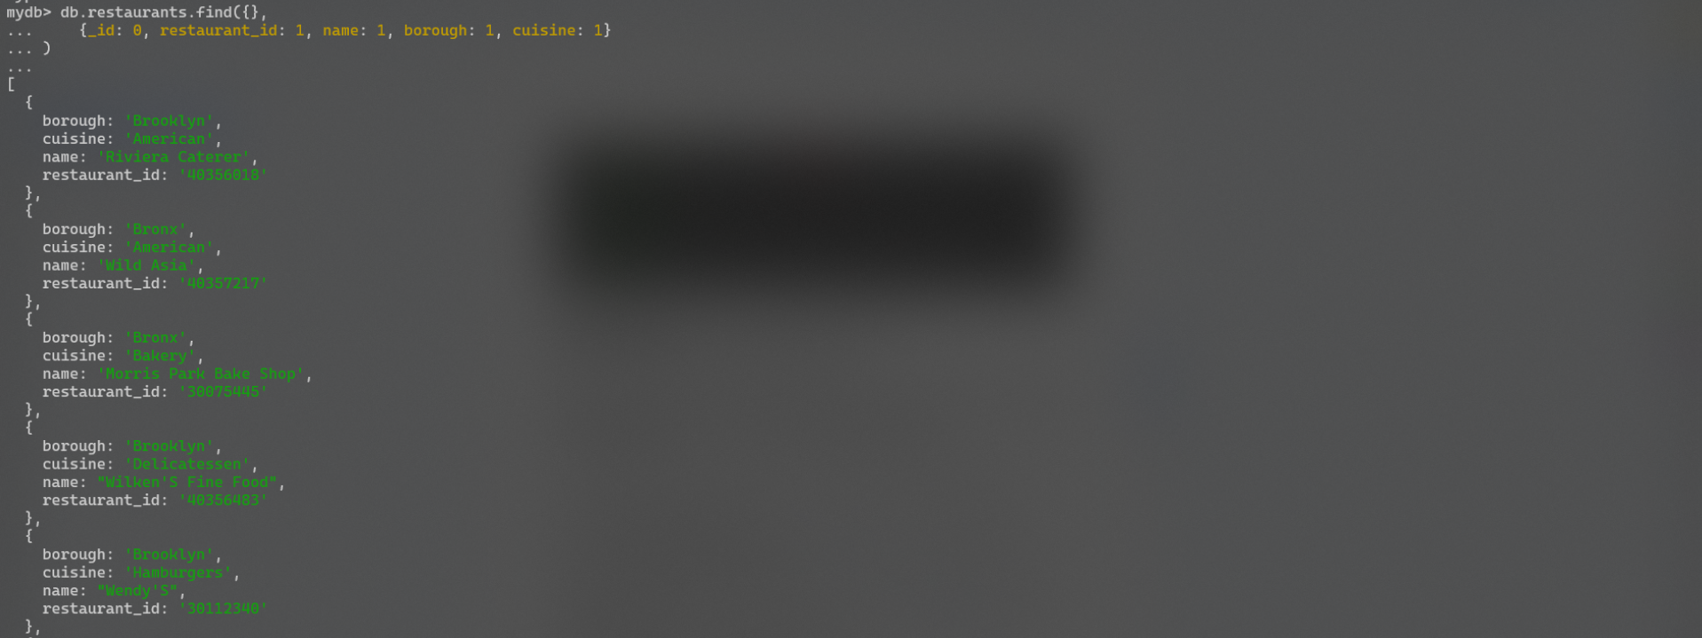

**4. Write a MongoDB query to display the fields restaurant_id, name, borough and zip code, but exclude the field _id for all the documents in the collection restaurant.**

**db.restaurants.find({},**

**{_id: 0, restaurant_id: 1, name: 1, borough: 1, cuisine: 1, 'address.zipcode': 1}**

**)**

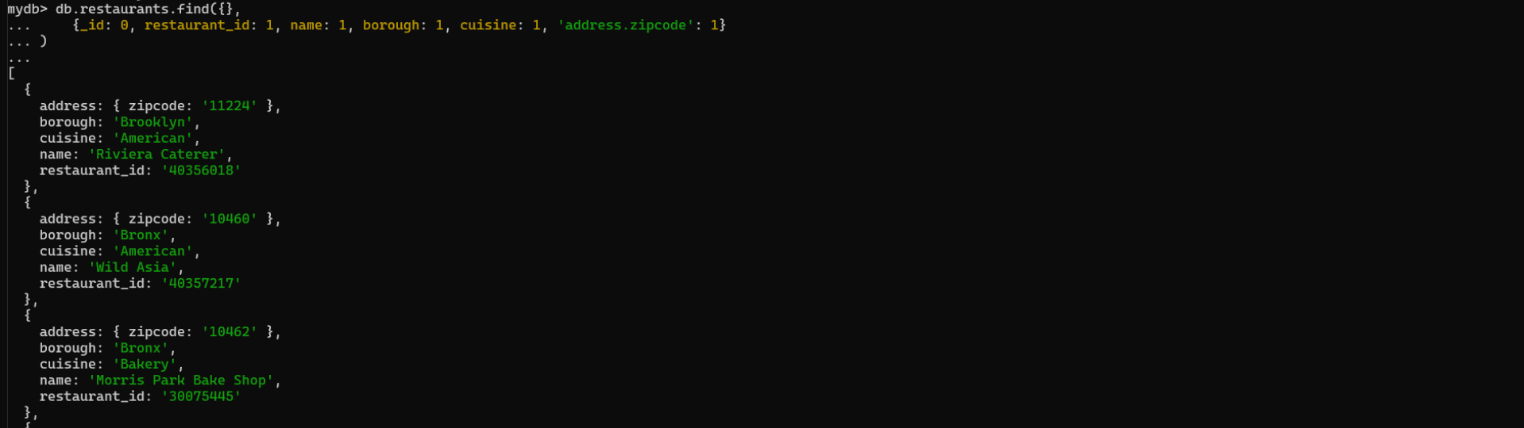

**5. Write a MongoDB query to display all the restaurant which is in the borough Bronx**

**db.restaurants.find({borough: 'Bronx'})**

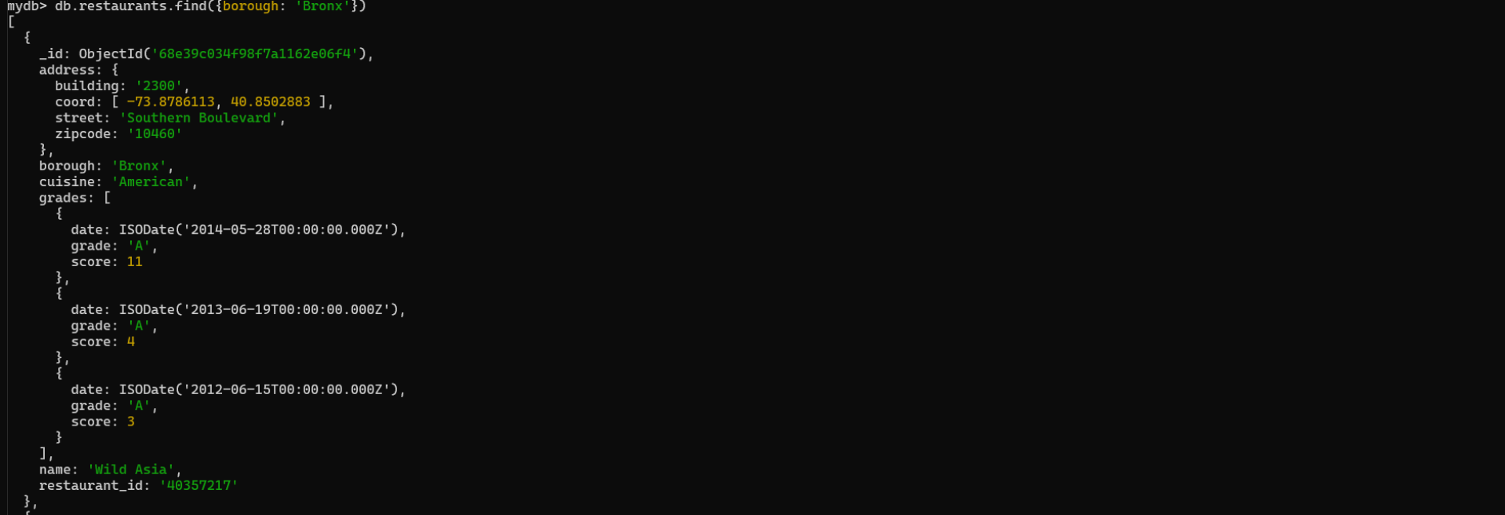

**6. Write a MongoDB query to display the first 5 restaurant which is in the borough Bronx.**

**db.restaurants.find({borough: 'Bronx'}).limit(5)**

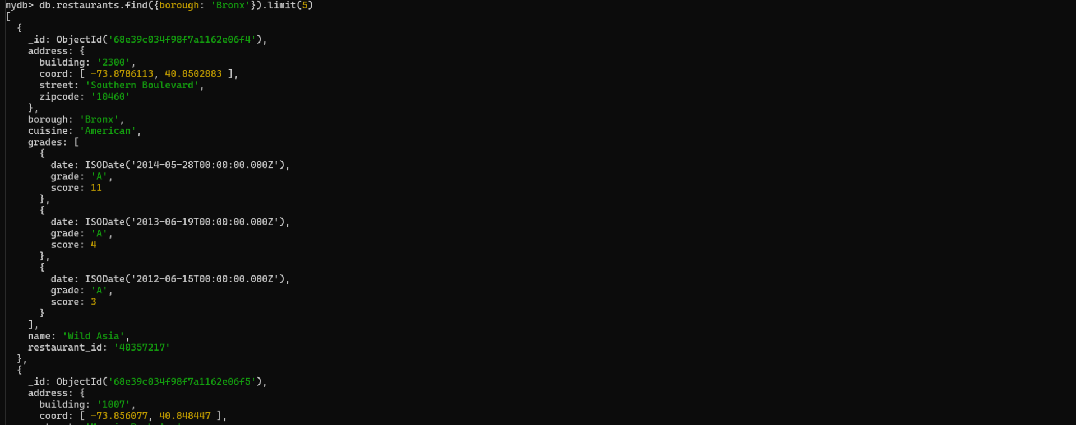

**7. Write a MongoDB query to display the next 5 restaurants after skipping first 5 which are in the borough Bronx.**

**db.restaurants.find({borough: 'Bronx'}).limit(5).skip(5)**

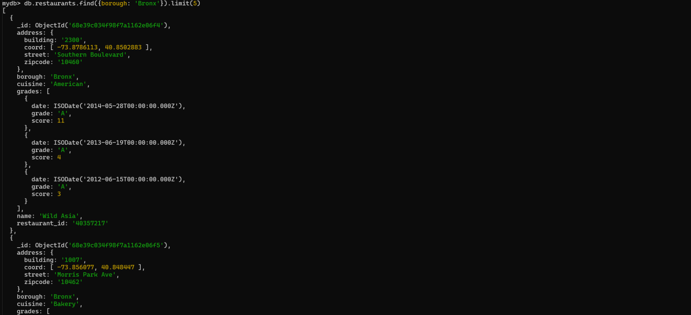

**8. Write a MongoDB query to find the restaurants who achieved a score more than 90.**

**db.restaurants.find({'grades.score': {$gt: 90}})**

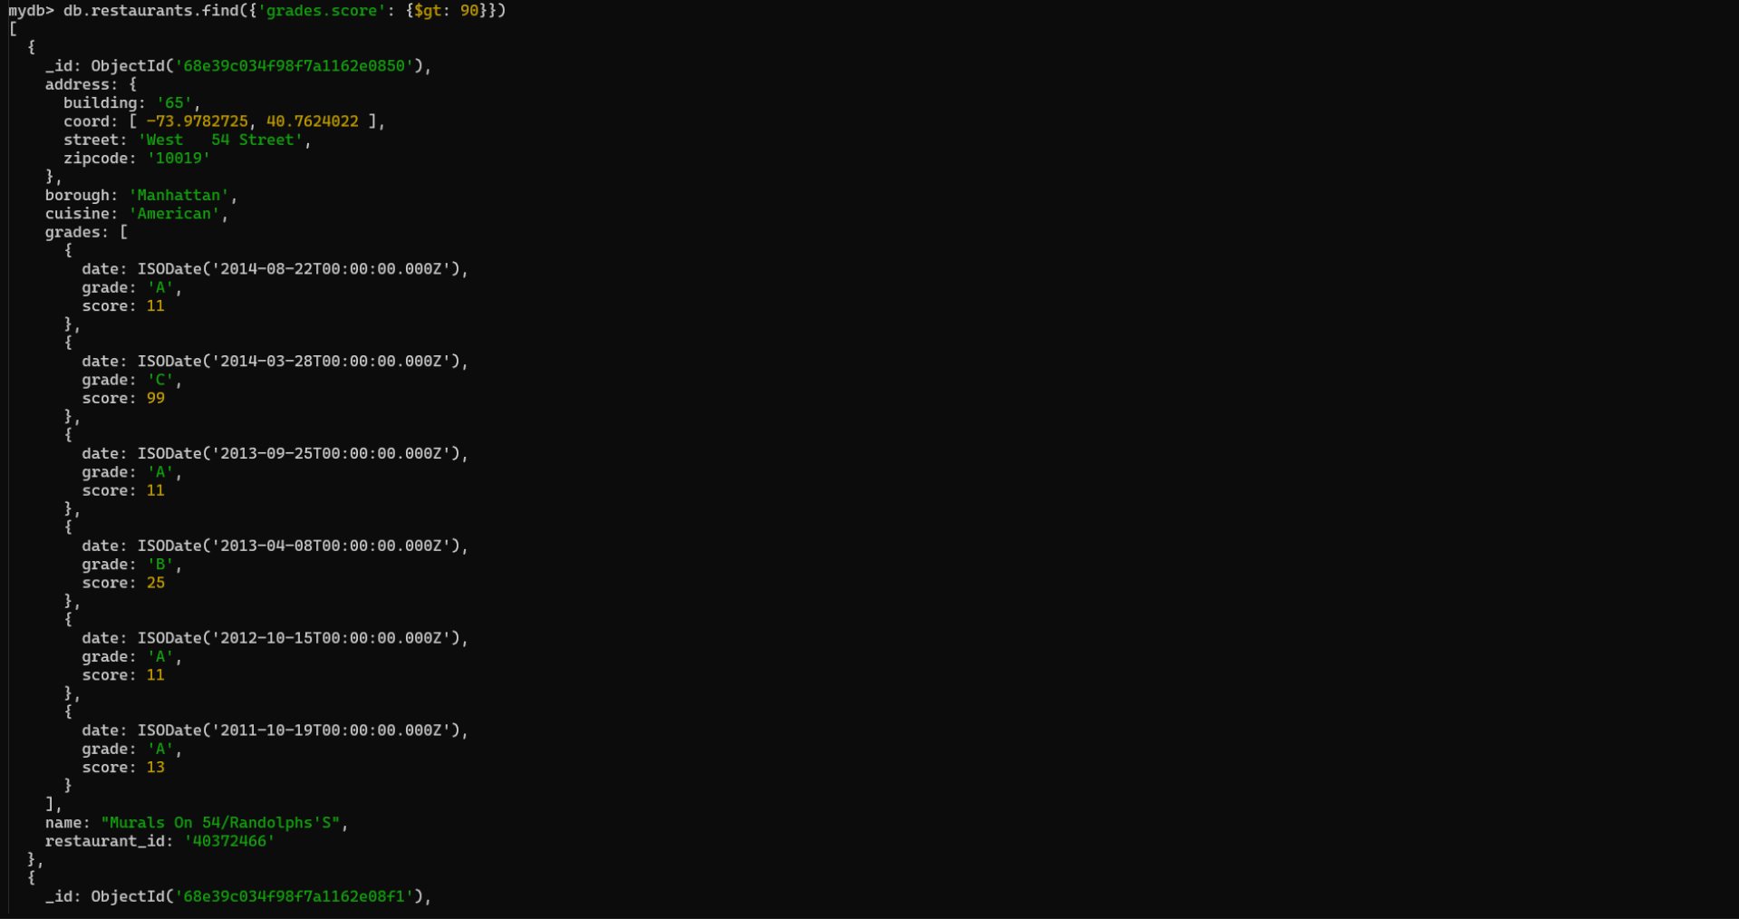

**9. Write a MongoDB query to find the restaurants that achieved a score, more than 80 but less than 100.**

**db.restaurants.find({'grades.score': {$gt: 90, $lt: 100}})**

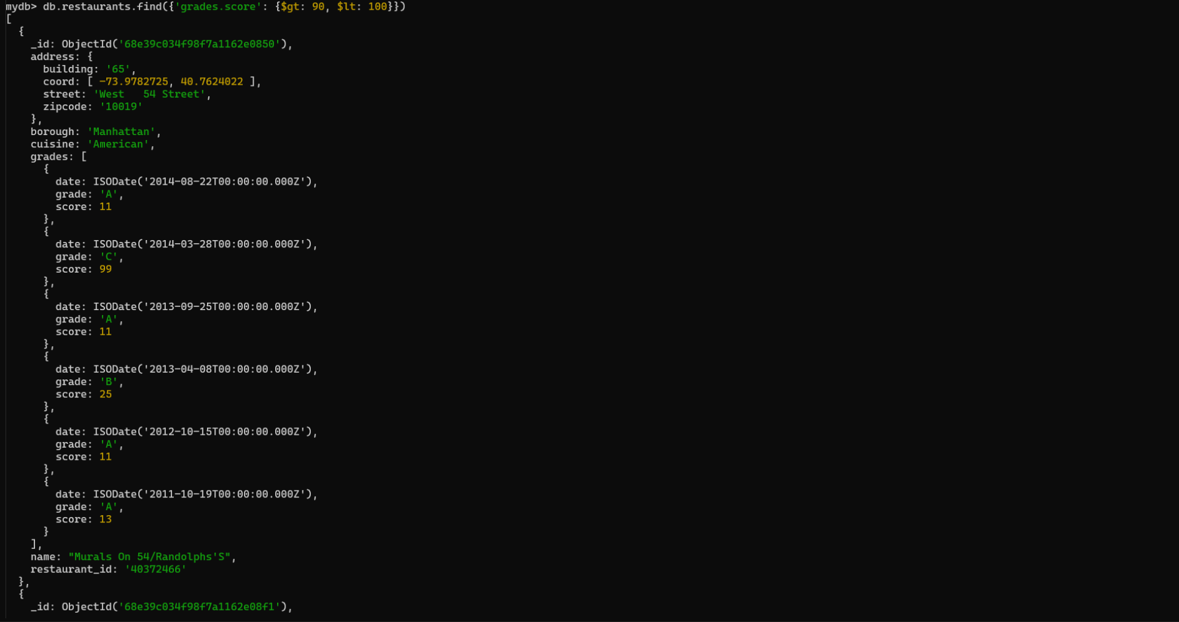

**10. Write a MongoDB query to find the restaurants which locate in latitude value less than -95.754168.**

**db.restaurants.find({'address.coord.0': {$lt: -95.754168}})**

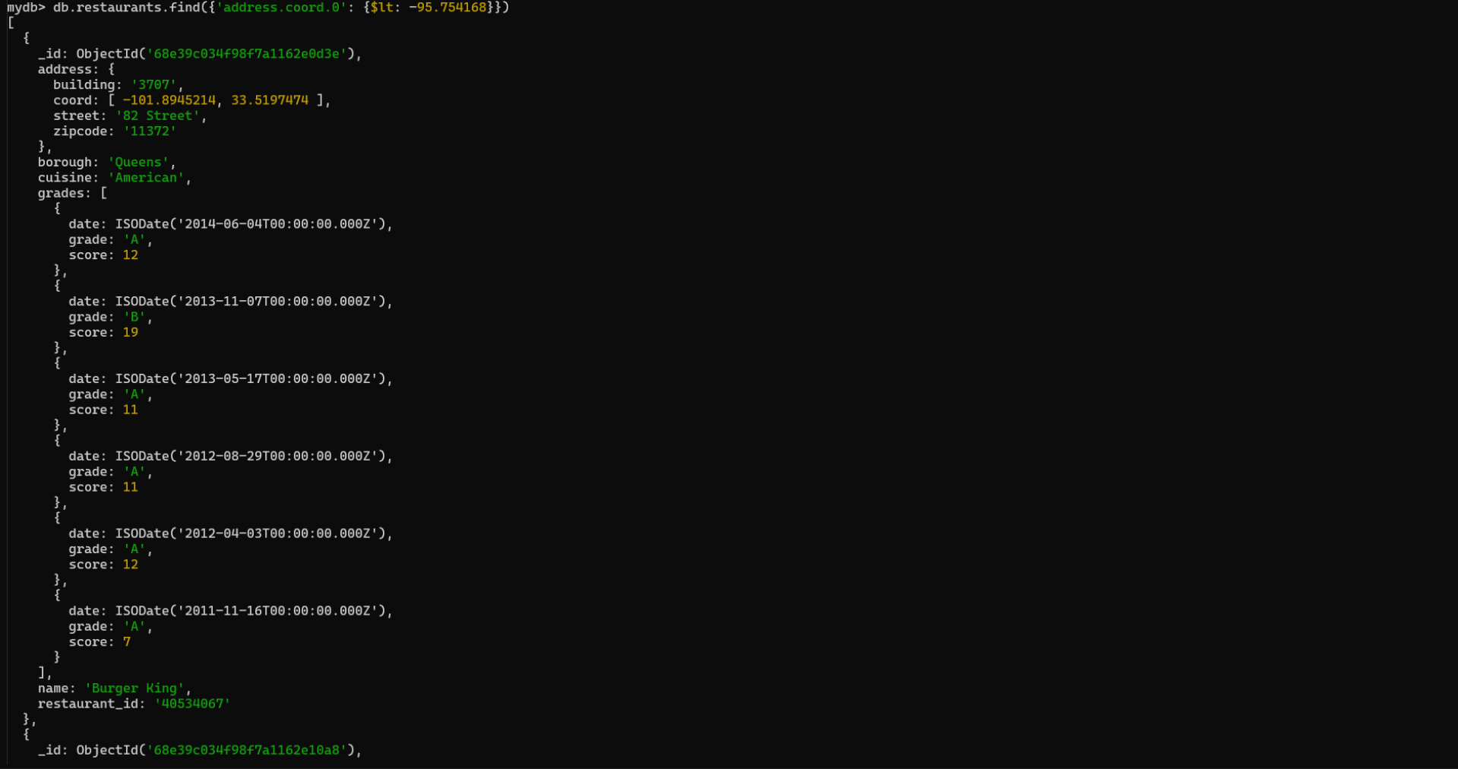

**11. Write a MongoDB query to find the restaurants that do not prepare any cuisine of 'American' and their grade score more than 70 and latitude less than -65.754168.**

**// db.restaurants.find({{cuisine: 'American'},{'grades.score': $gt: 70}, {'address.coord.0': {$lt:-65.754168}}})**

**db.restaurants.find({**

**cuisine : {$nin :['American']},**

**'grades.score':{$gt:70},**

**'address.coord.0':{$lt:-65.754168}**

**})**

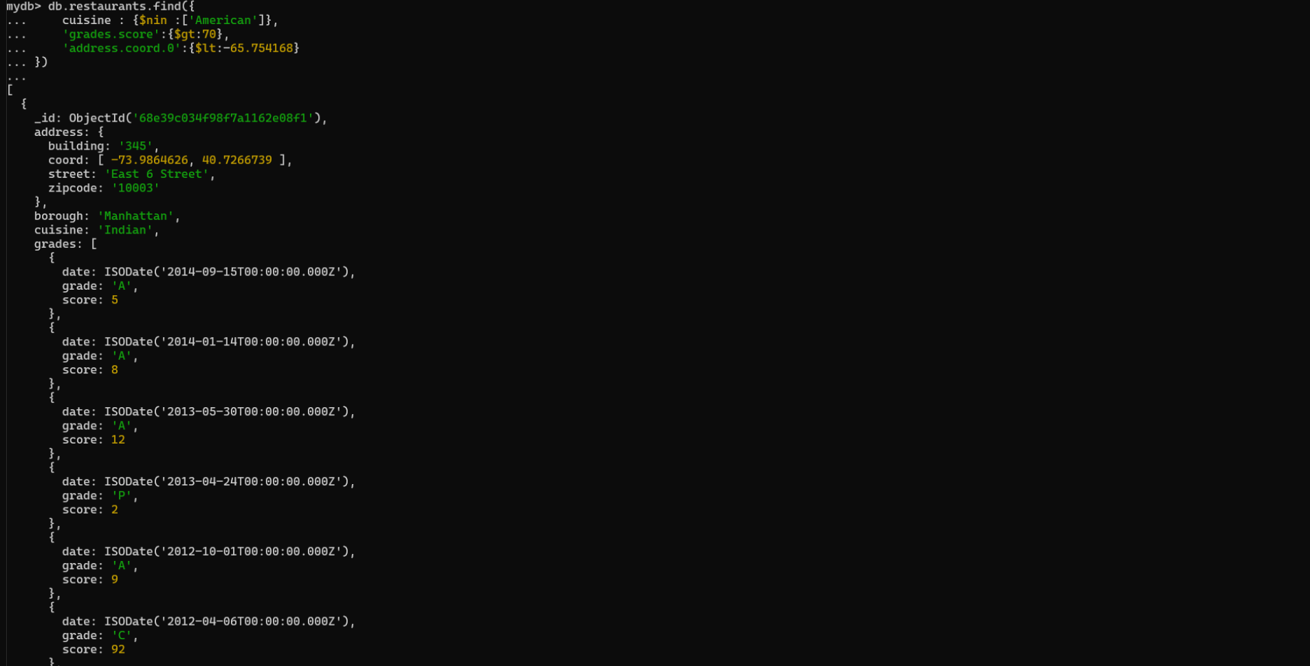

**12. Write a MongoDB query to find the restaurants which do not prepare any cuisine of 'American' and achieved a score more than 70 and located in the longitude less than -65.754168.**

**db.restaurants.find({**

**cuisine : {$nin :['American']},**

**'grades.score':{$gt:70},**

**'address.coord.1':{$lt:-65.754168}**

**})**



**13. Write a MongoDB query to find the restaurants which do not prepare any cuisine of 'American' and achieved a grade point 'A' not belongs to the borough Brooklyn. The document must be displayed according to the cuisine in descending order.**

**db.restaurants.find({**

**cusinie: {**

**$nin: ['American']}, 'grades.grade' : 'A', 'borough':**

**{$nin: ['Brooklyn']}}).sort({**

**cuisine: -1})**

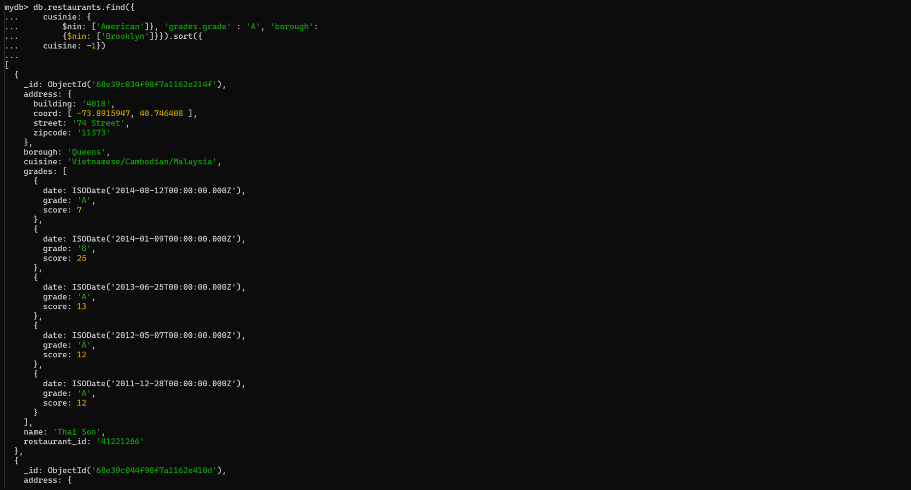

**14. Write a MongoDB query to find the restaurant Id, name, borough and cuisine for those restaurants which contain 'Wil' as first three letters for its name.**

**db.restaurants.find(**

**{ name: { $regex: '^Wil', $options: 'i' } },**

**{ restaurant_id: 1, name: 1, borough: 1, cuisine: 1, _id: 0 }**

**)**

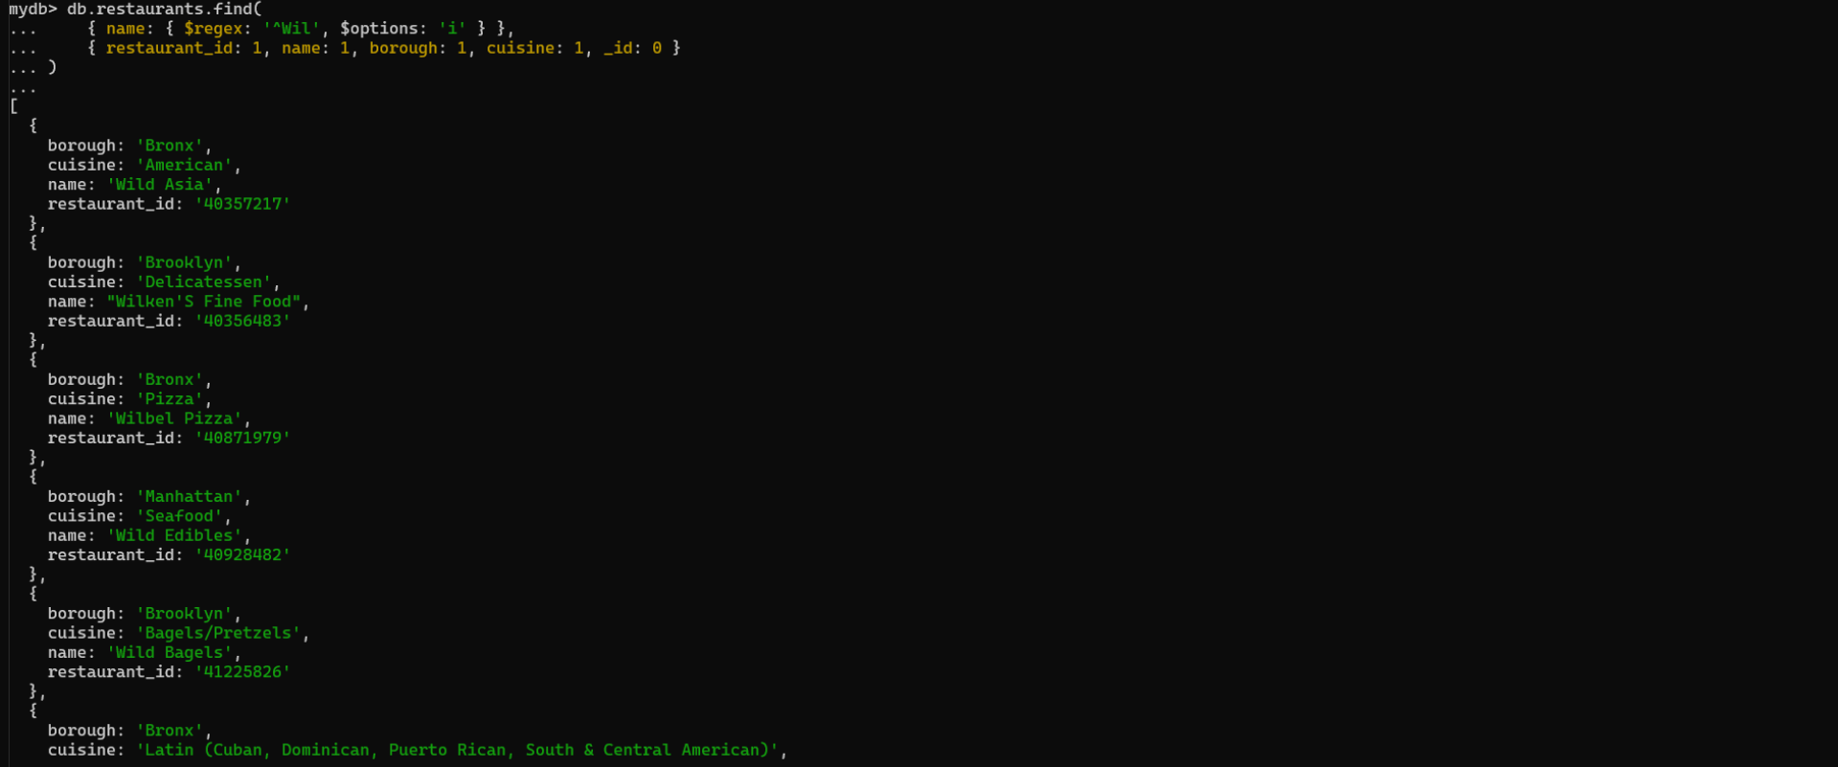

**15. Write a MongoDB query to find the restaurant Id, name, borough and cuisine for those restaurants which contain 'ces' as last three letters for its name.**

**db.restaurants.find(**

**{name: { $regex: 'ces$'}},**

**{ restaurant_id: 1, name: 1, borough: 1, cuisine: 1, _id: 0 }**

**)**

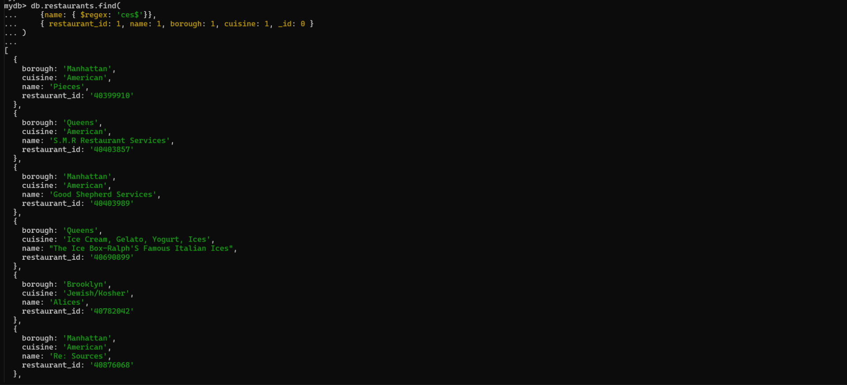

**16. Write a MongoDB query to find the restaurant Id, name, borough and cuisine for those restaurants which contain 'Reg' as three letters somewhere in its name.**

**db.restaurants.find(**

**{name: { $regex: 'Reg'}},**

**{ restaurant_id: 1, name: 1, borough: 1, cuisine: 1, _id: 0 }**

**)**

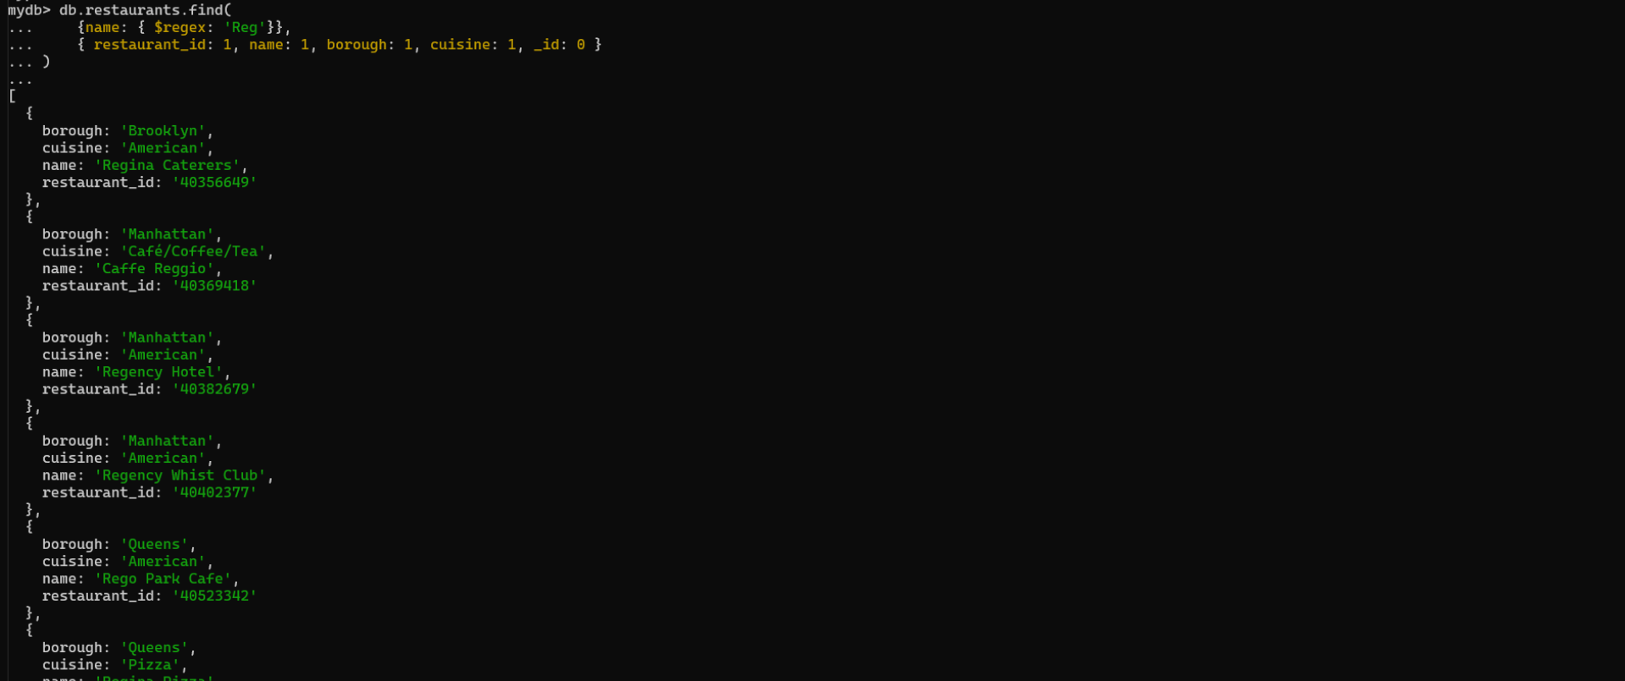

**17. Write a MongoDB query to find the restaurants which belong to the borough Bronx and prepared either American or Chinese dish.**

**db.restaurants.find({ borough: 'Bronx', cuisine: { $in: ['American', 'Chinese'] } })**

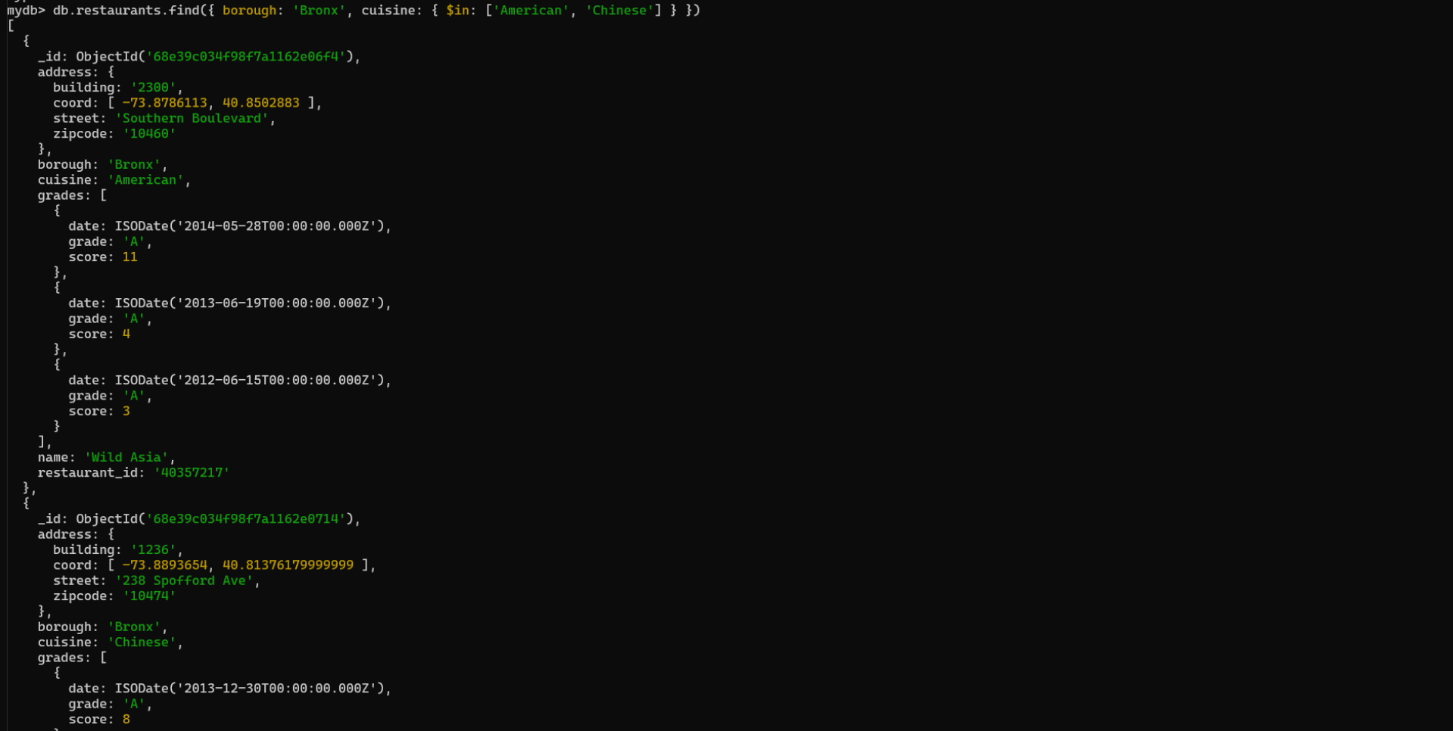

**18. Write a MongoDB query to find the restaurant Id, name, borough and cuisine for those restaurants which belong to the borough Staten Island or Queens or Bronx or Brooklyn.**

**db.restaurants.find(**

**{ borough: { $in: ['Staten Island', 'Queens', 'Bronx', 'Brooklyn'] } },**

**{ restaurant_id: 1, name: 1, borough: 1, cuisine: 1, _id: 0 }**

**)**

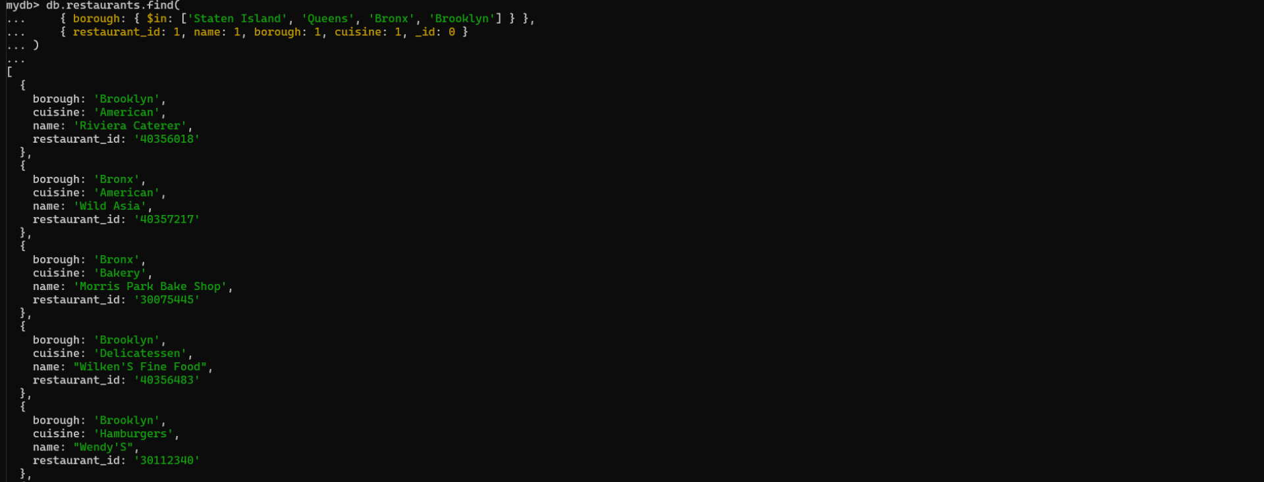

**19. Write a MongoDB query to find the restaurant Id, name, borough and cuisine for those restaurants which are not belonging to the borough Staten Island or Queens or Bronx or Brooklyn.**

**db.restaurants.find(**

**{ borough: { $nin: ['Staten Island', 'Queens', 'Bronx', 'Brooklyn'] } },**

**{ restaurant_id: 1, name: 1, borough: 1, cuisine: 1, _id: 0 }**

**)**

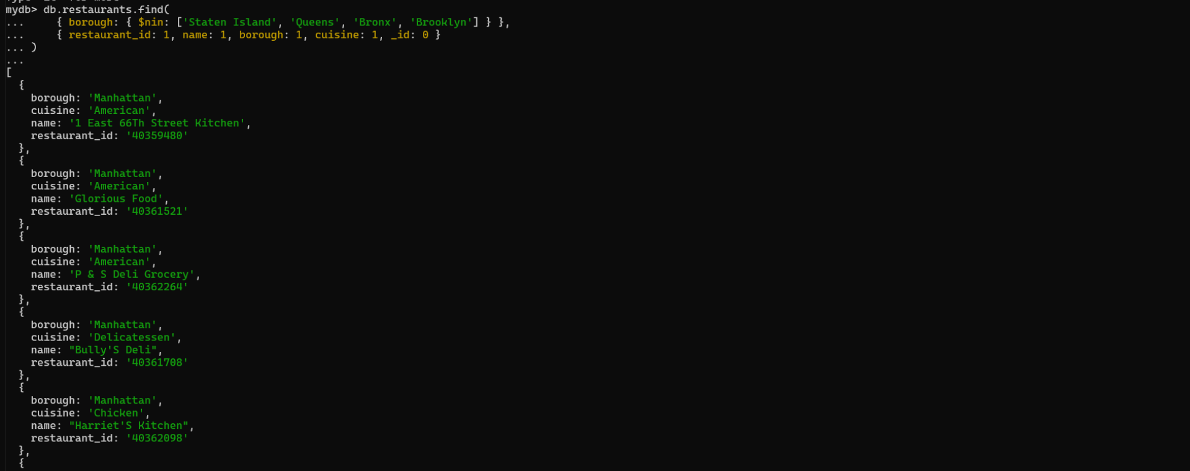

**20. Write a MongoDB query to find the restaurant Id, name, borough and cuisine for those restaurants which achieved a score which is not more than 10.**

**db.restaurants.find(**

**{ 'grades.score': { $lte: 10 } },**

**{ restaurant_id: 1, name: 1, borough: 1, cuisine: 1, _id: 0 }**

**)**

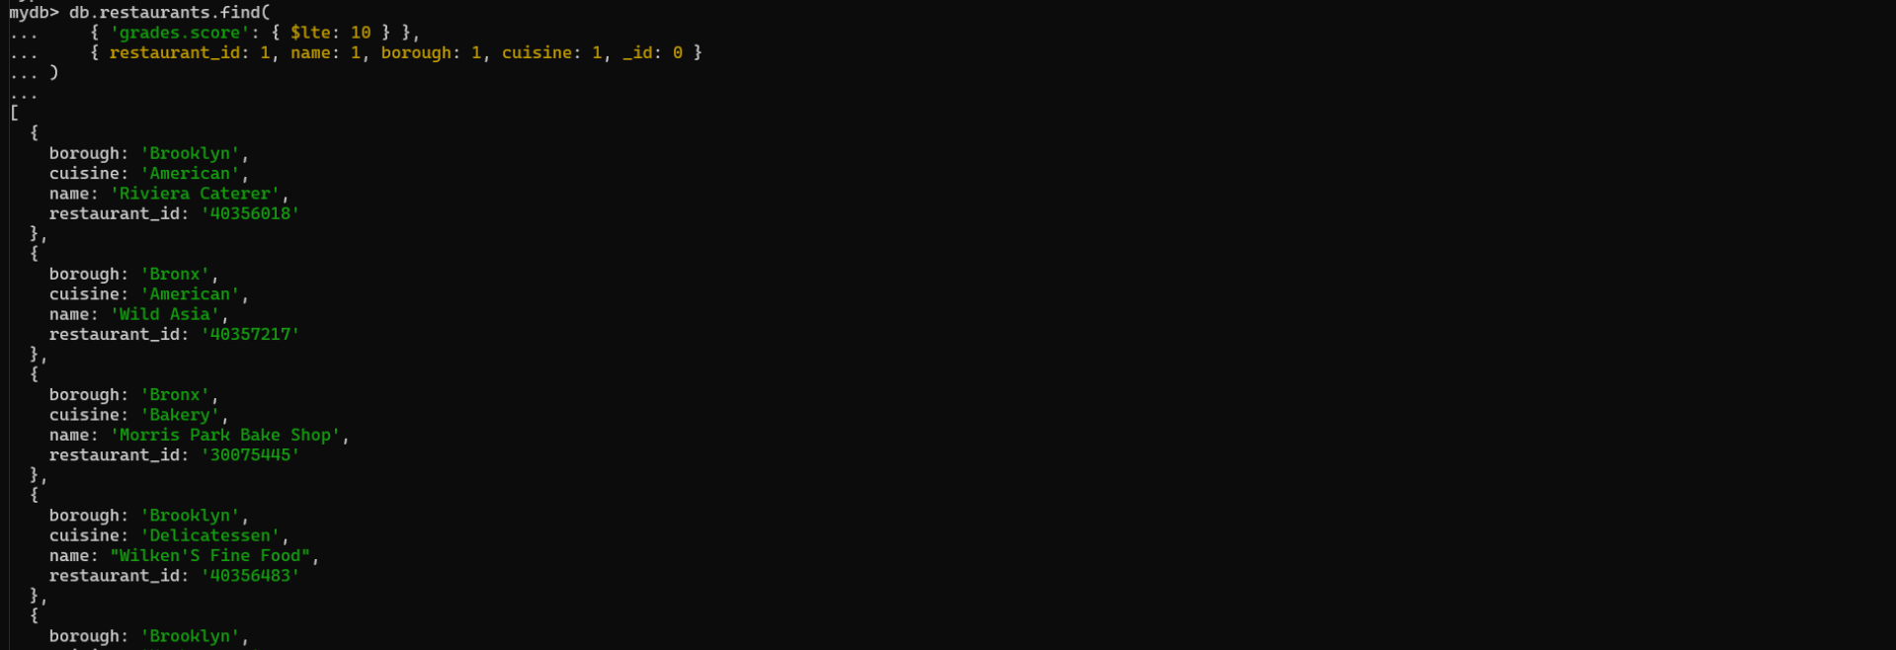

**21. Write a MongoDB query to find the restaurant Id, name, borough and cuisine for those restaurants which prepared dish except 'American' and 'Chinees' or restaurant's name begins with letter 'Wil'.**

**db.restaurants.find(**

**{**

**$or: [**

**{ cuisine: { $nin: ['American', 'Chinees'] } },**

**{ name: { $regex: '^Wil', $options: 'i' } }**

**]**

**},**

**{ restaurant_id: 1, name: 1, borough: 1, cuisine: 1, _id: 0 }**

**)**

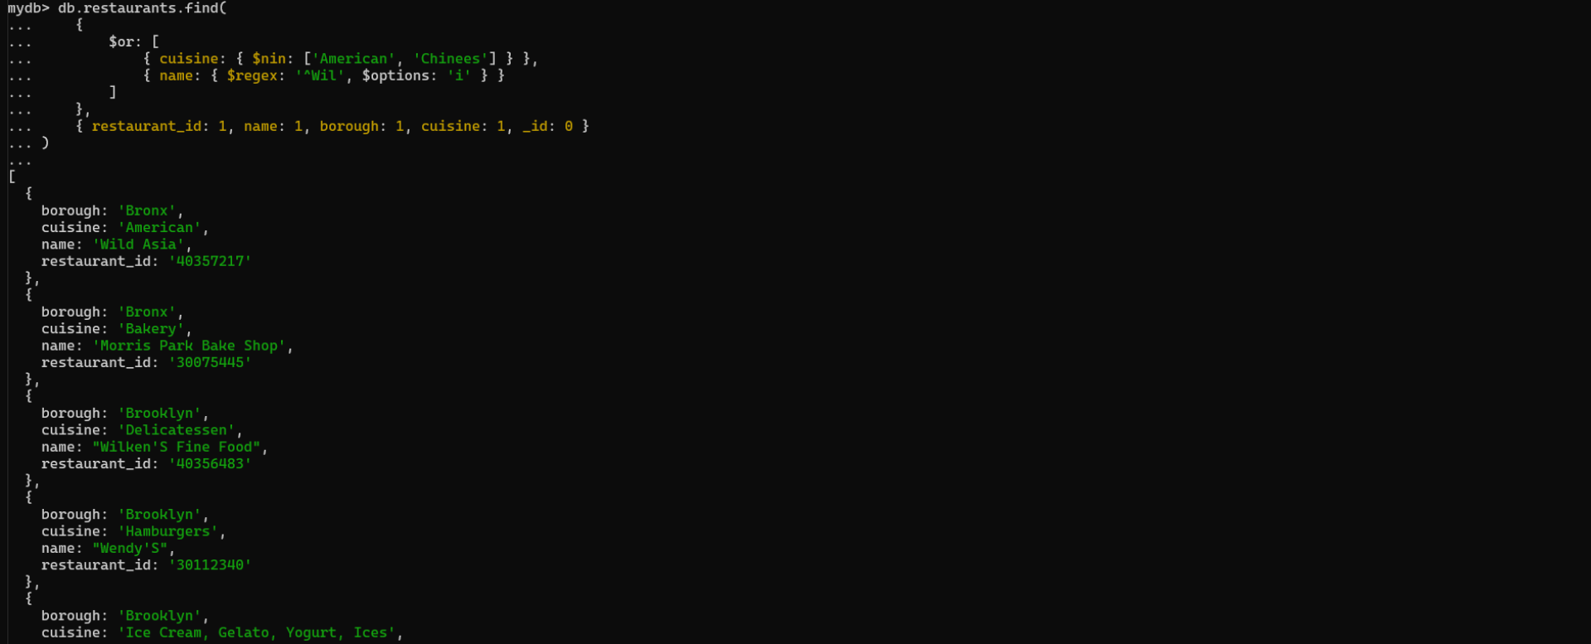

**Write a MongoDB query to find the restaurant Id, name, and grades for those restaurants which achieved a grade of "A" and scored 11 on an ISODate "2014-08-11T00:00:00Z" among many of survey dates**

**db.restaurants.find(**

**{ grades: { $elemMatch: { grade: 'A', score: 11, date: ISODate('2014-08-11T00:00:00Z') } } },**

**{ restaurant_id: 1, name: 1, grades: 1, _id: 0 }**

**)**

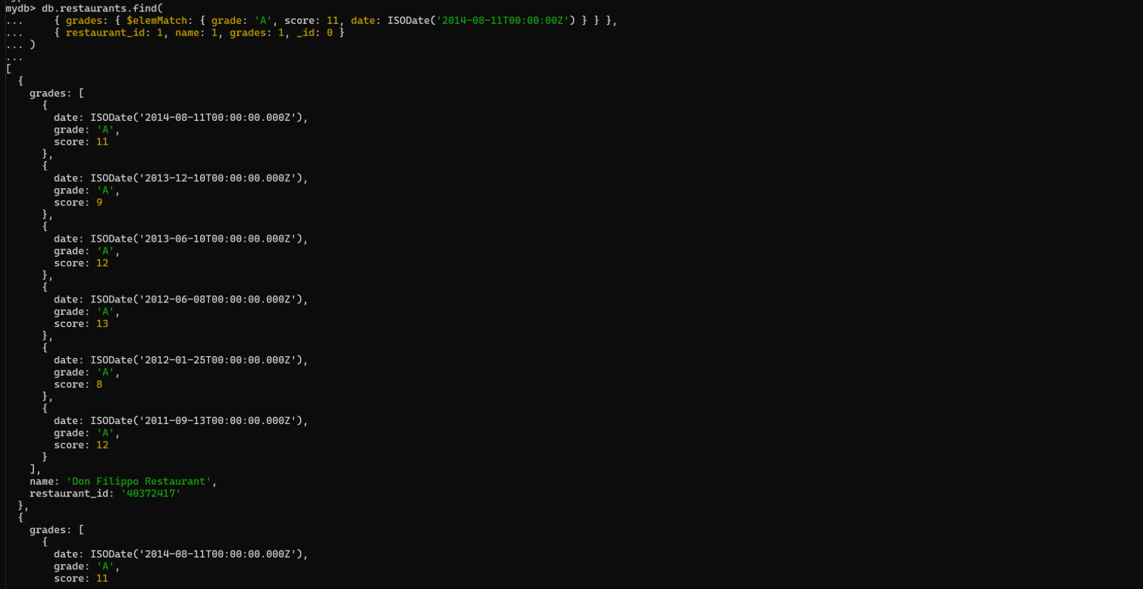

**Write a MongoDB query to find the restaurant Id, name and grades for those restaurants where the 2nd element of grades array contains a grade of "A" and score 9 on an ISODate "2014-08-11T00:00:00Z".**

**db.restaurants.find(**

**{ 'grades.1.grade': 'A', 'grades.1.score': 9, 'grades.1.date': ISODate('2014-08-11T00:00:00Z') },**

**{ restaurant_id: 1, name: 1, grades: 1, _id: 0 }**

**)**

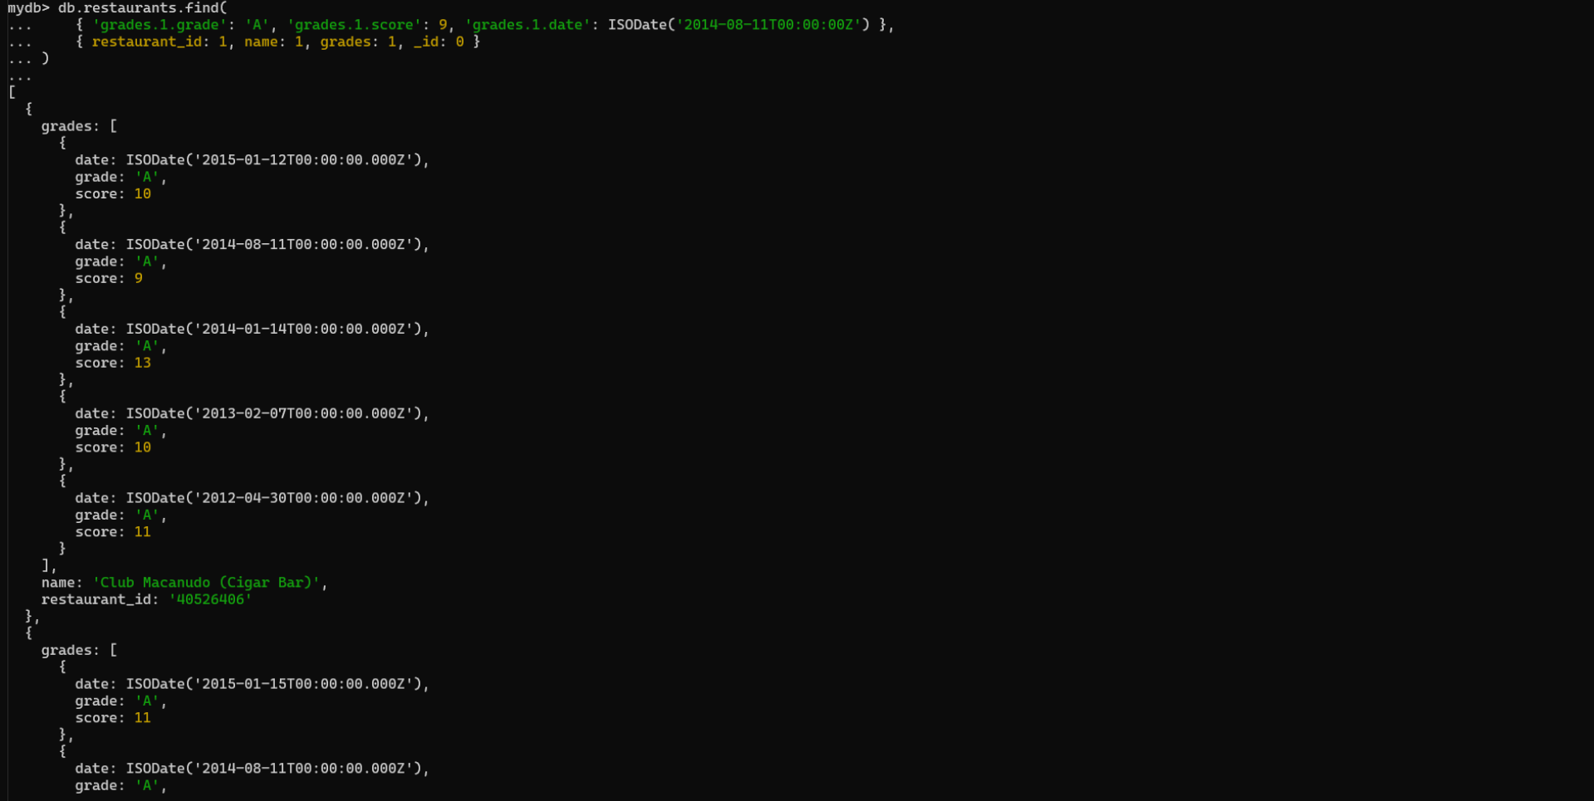

**Write a MongoDB query to find the restaurant Id, name, address and geographical location for those restaurants where 2nd element of coord array contains a value which is more than 42 and upto 52**

**db.restaurants.find(**

**{ 'address.coord.1': { $gt: 42, $lte: 52 } },**

**{ restaurant_id: 1, name: 1, 'address.coord': 1, _id: 0 }**

**)**

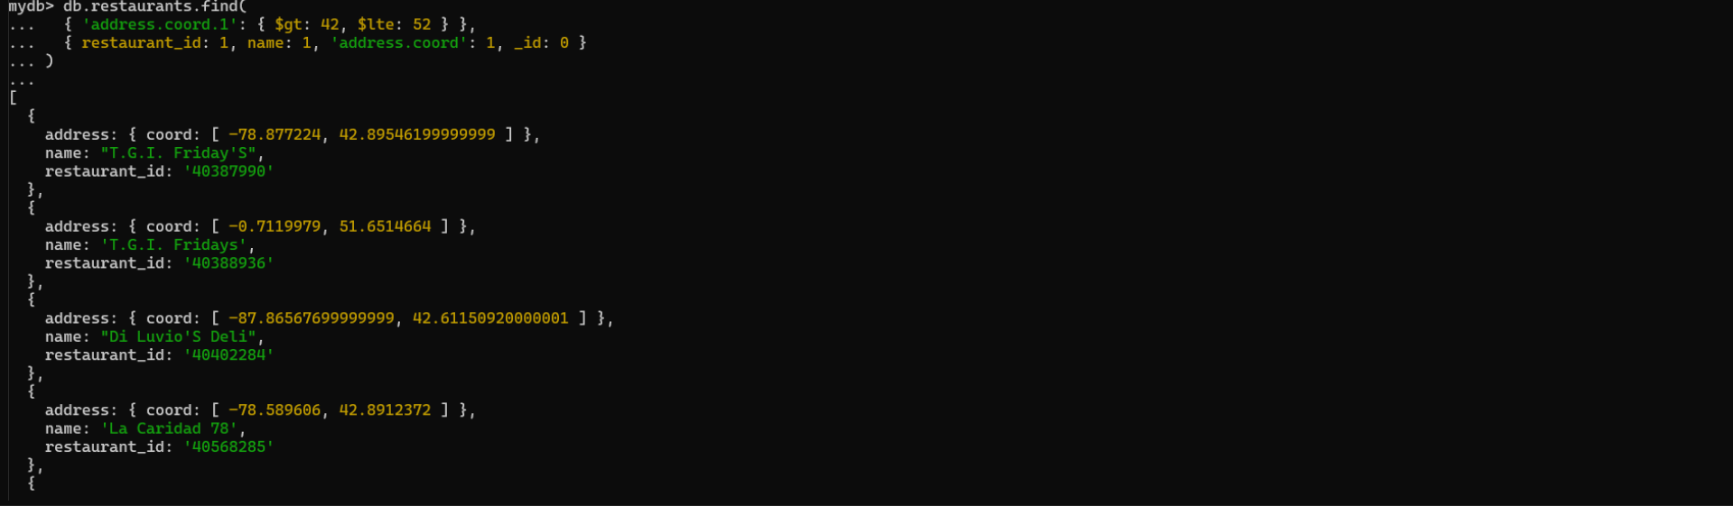

**25. Write a MongoDB query to arrange the name of the restaurants in ascending order along with all the columns.**

**db.restaurants.find().sort({ name: 1 })**

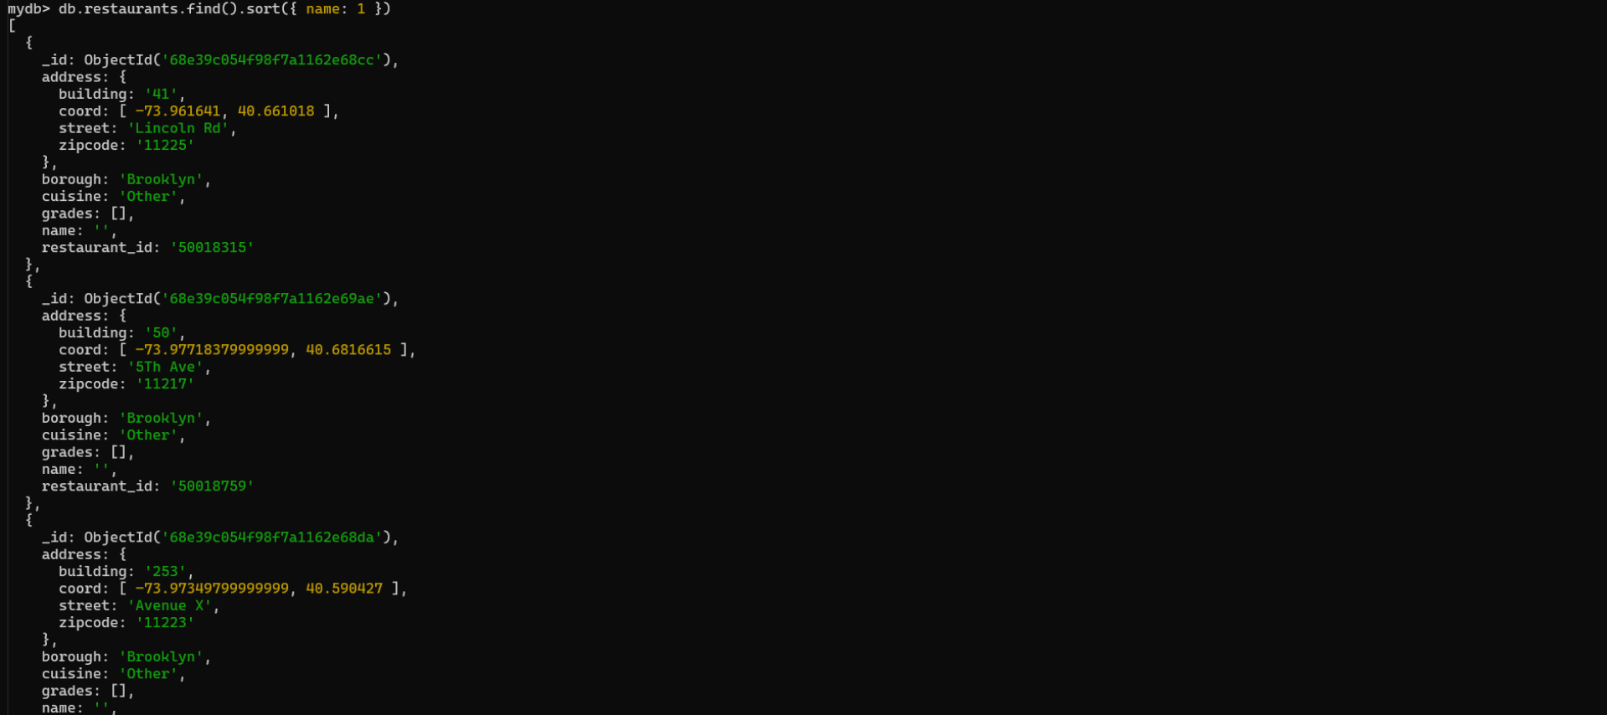

**Write a MongoDB query to arrange the name of the restaurants in descending along with all the columns.**

**db.restaurants.find().sort({ name: -1 })**

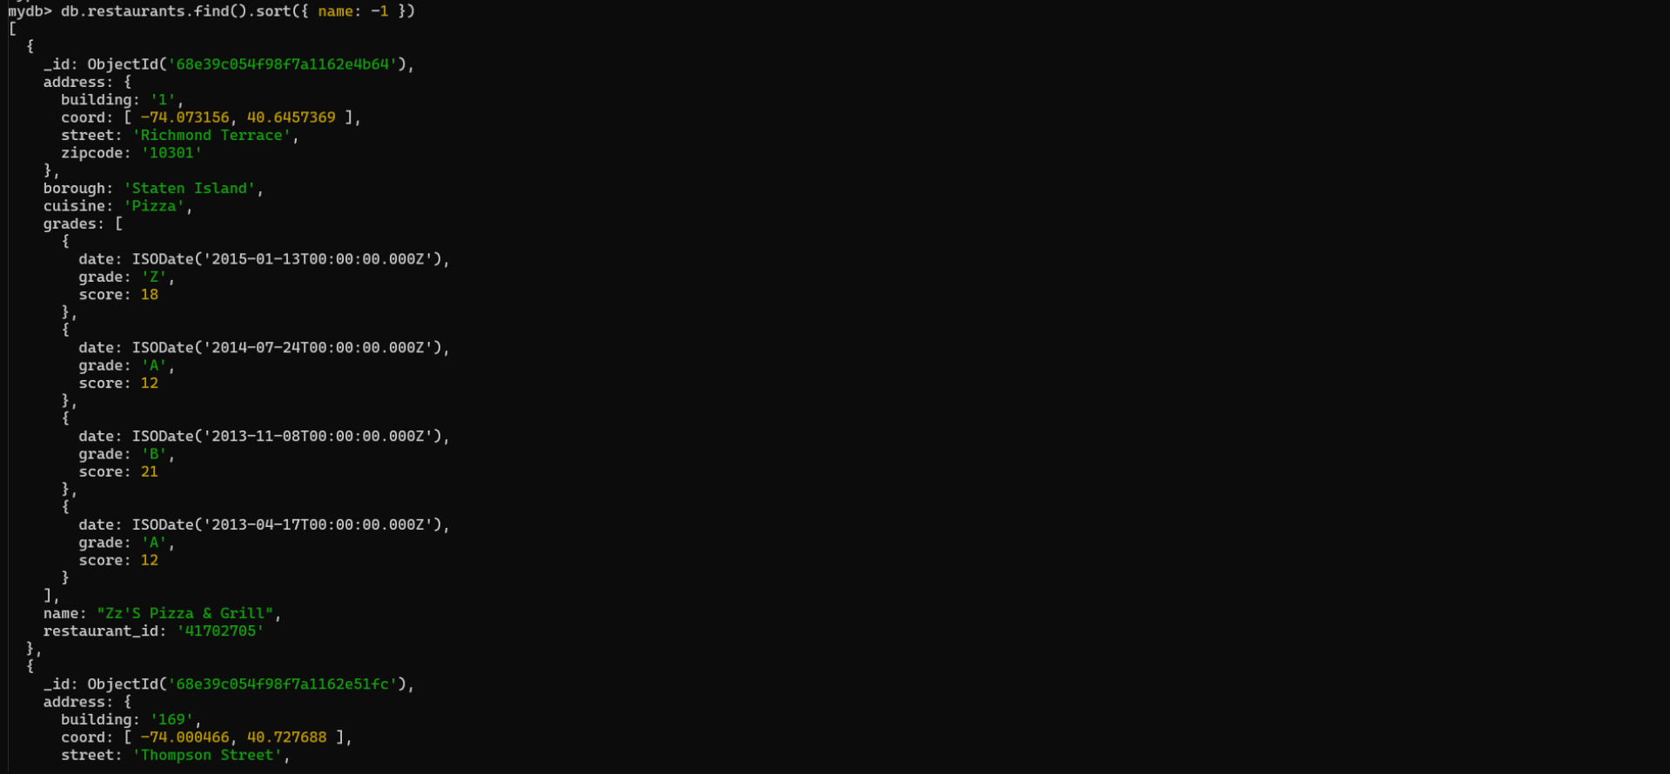

**Write a MongoDB query to arrange the name of the cuisine in ascending order and for that same cuisine borough should be in descending order.**

**db.restaurants.find().sort({ cuisine: 1, borough: -1 })**

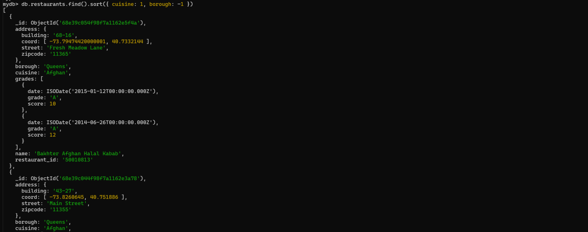

**Write a MongoDB query to know whether all the addresses contains the street or not.**

**db.restaurants.find({ 'address.street': { $exists: false } }).count()**



**MongoDB Assignment-2**

**Create a Employee Collection add 5 documents:**

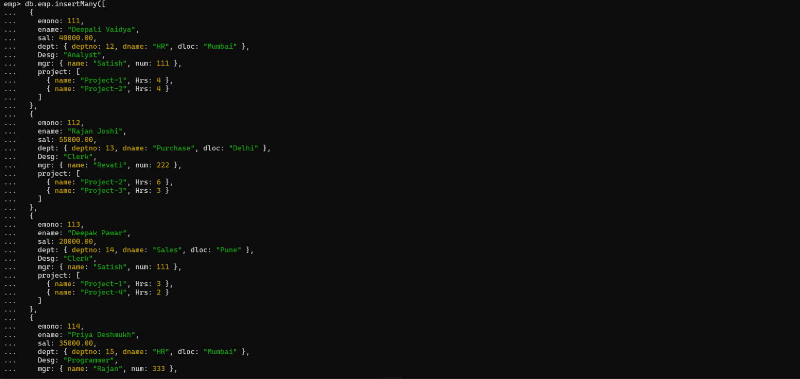

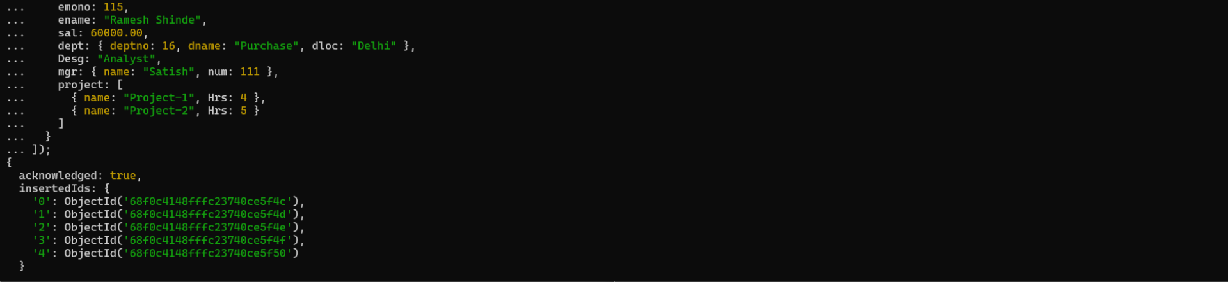

**1. All Employee’s with the desg as ‘CLERK’ are now called as (AO) Administrative Officers.**

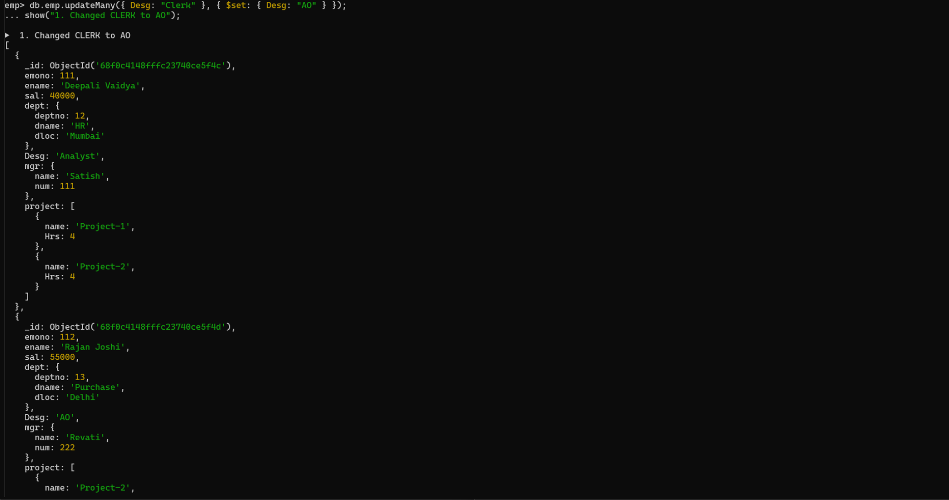

**2. Change the number of hours for project-1 to 5 for all employees with designation analyst.**

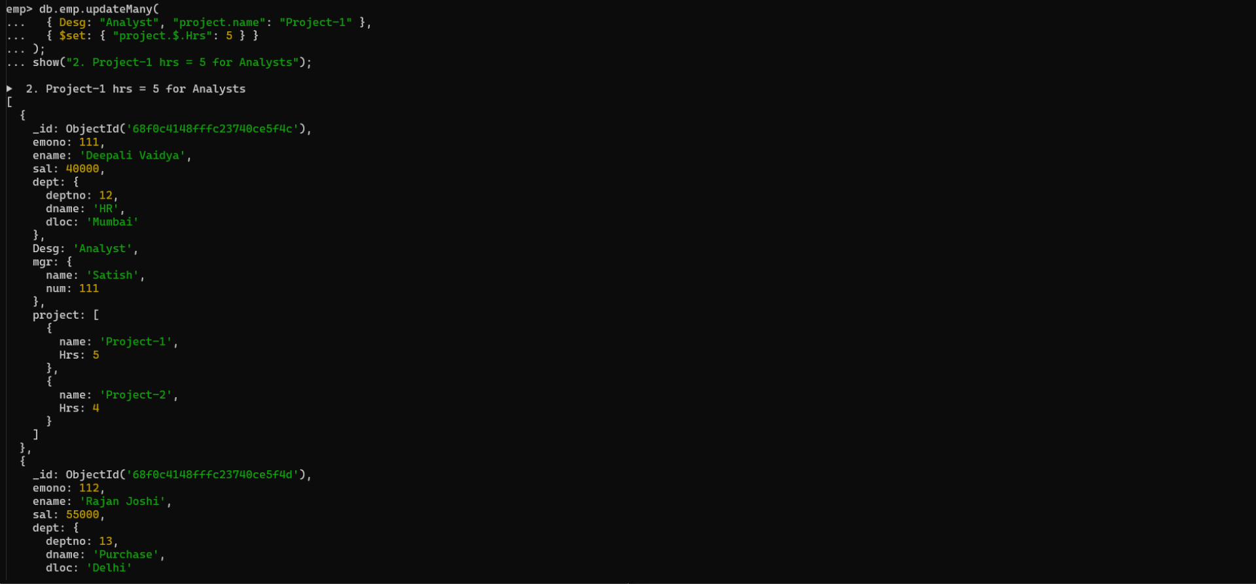

**3. Add 2 projects project-3 and project-4 for employee whose name starts with ”Deep” with 2 hrs**

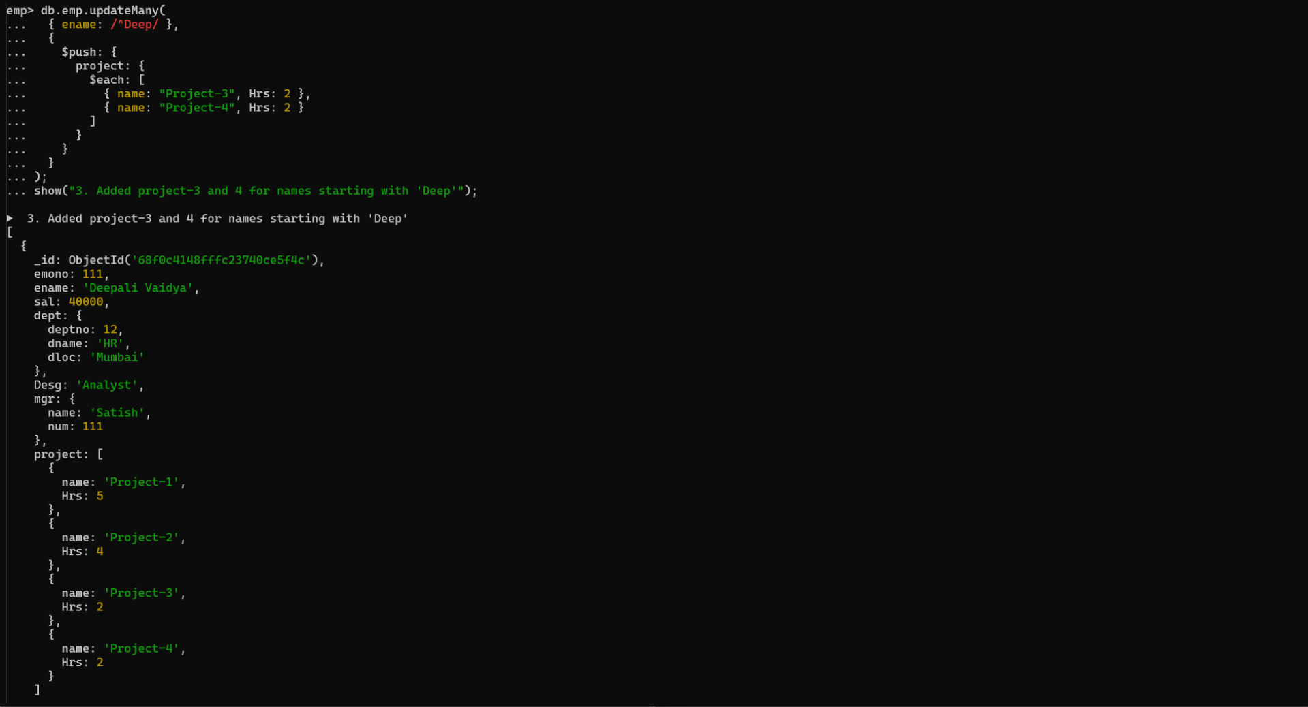

**4. Add bonus rs 2000 for all employees with salary > 50000**

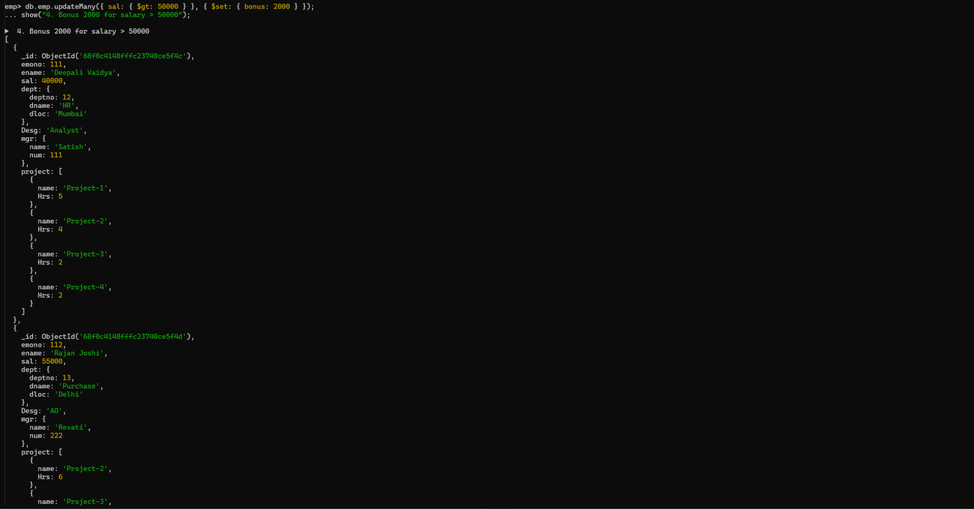

**5. add bonus 1500 if salary <50000 and > 30000**

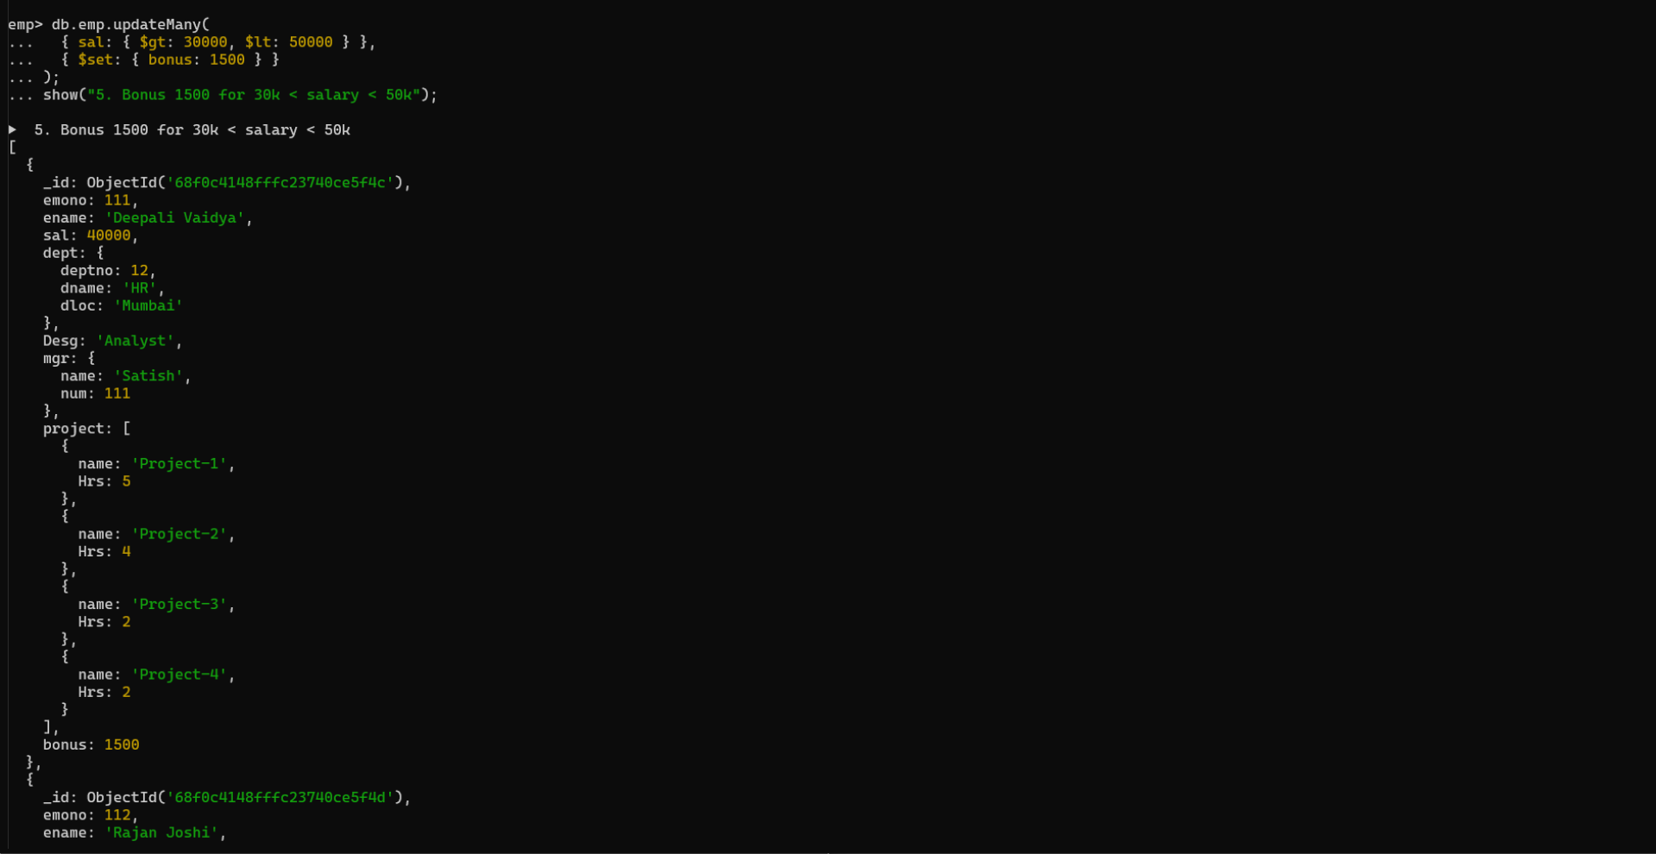

**6. add bonus 1000 if salary <=30000**

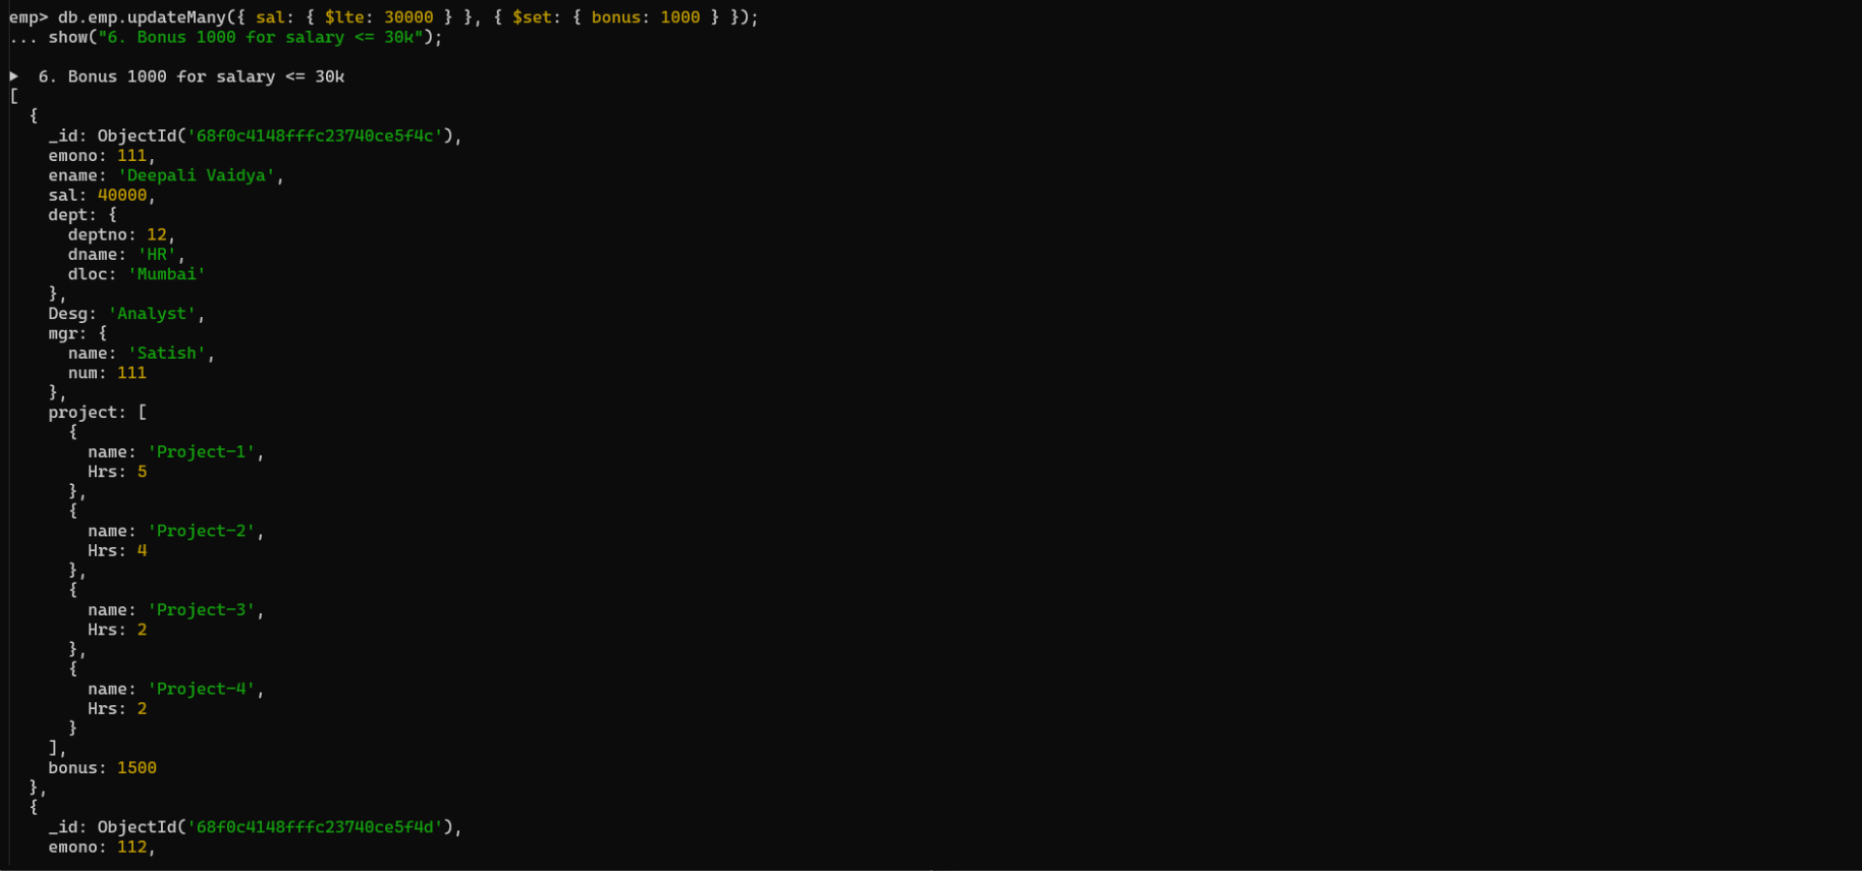

**7. Change manager name to Tushar for all employees whose manager is currently “satish” And manager number to 3333**

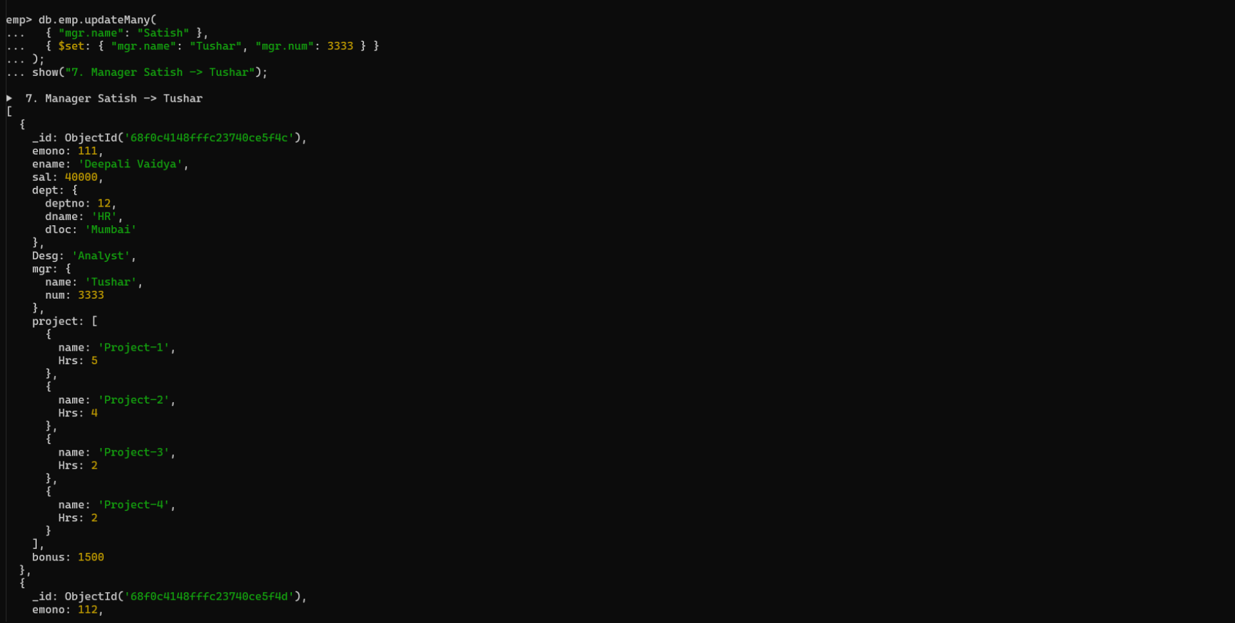

**8. Increase salary of all employees from “purchase department” by 15000**

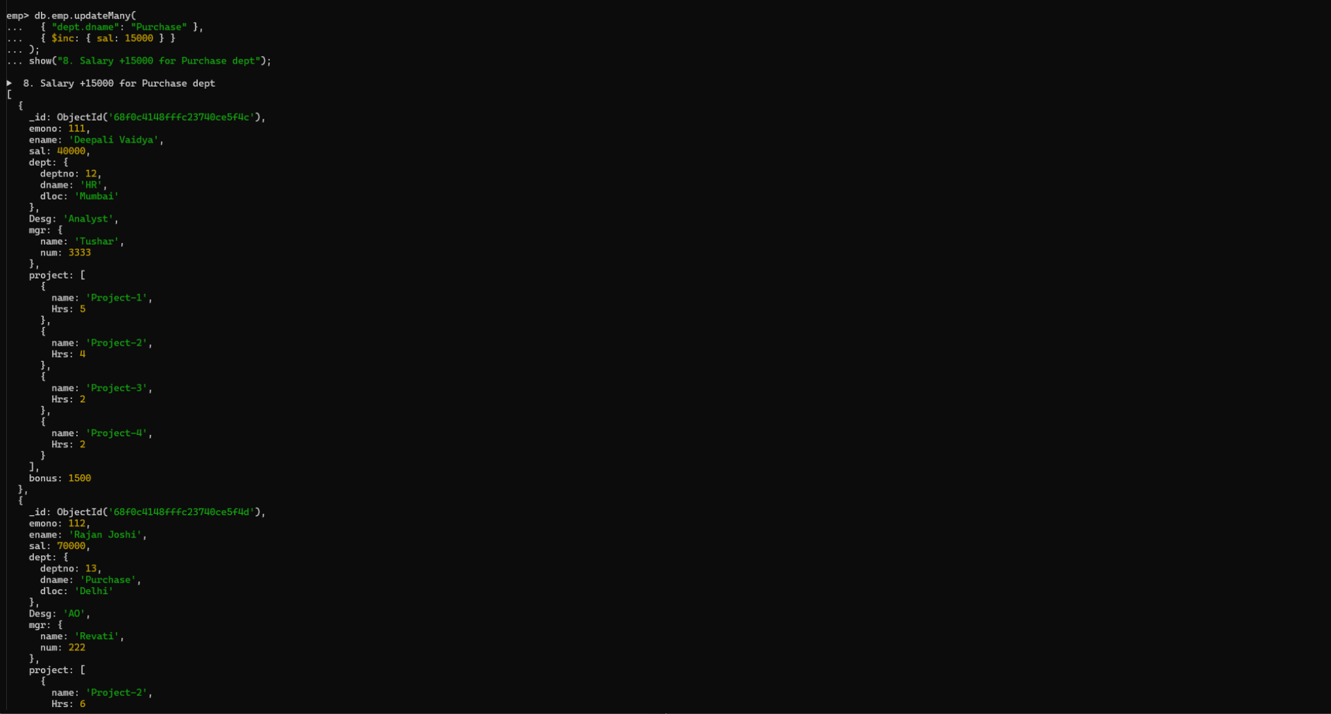

**9. Decrease number of hrs by 2 for all employees who are working on**

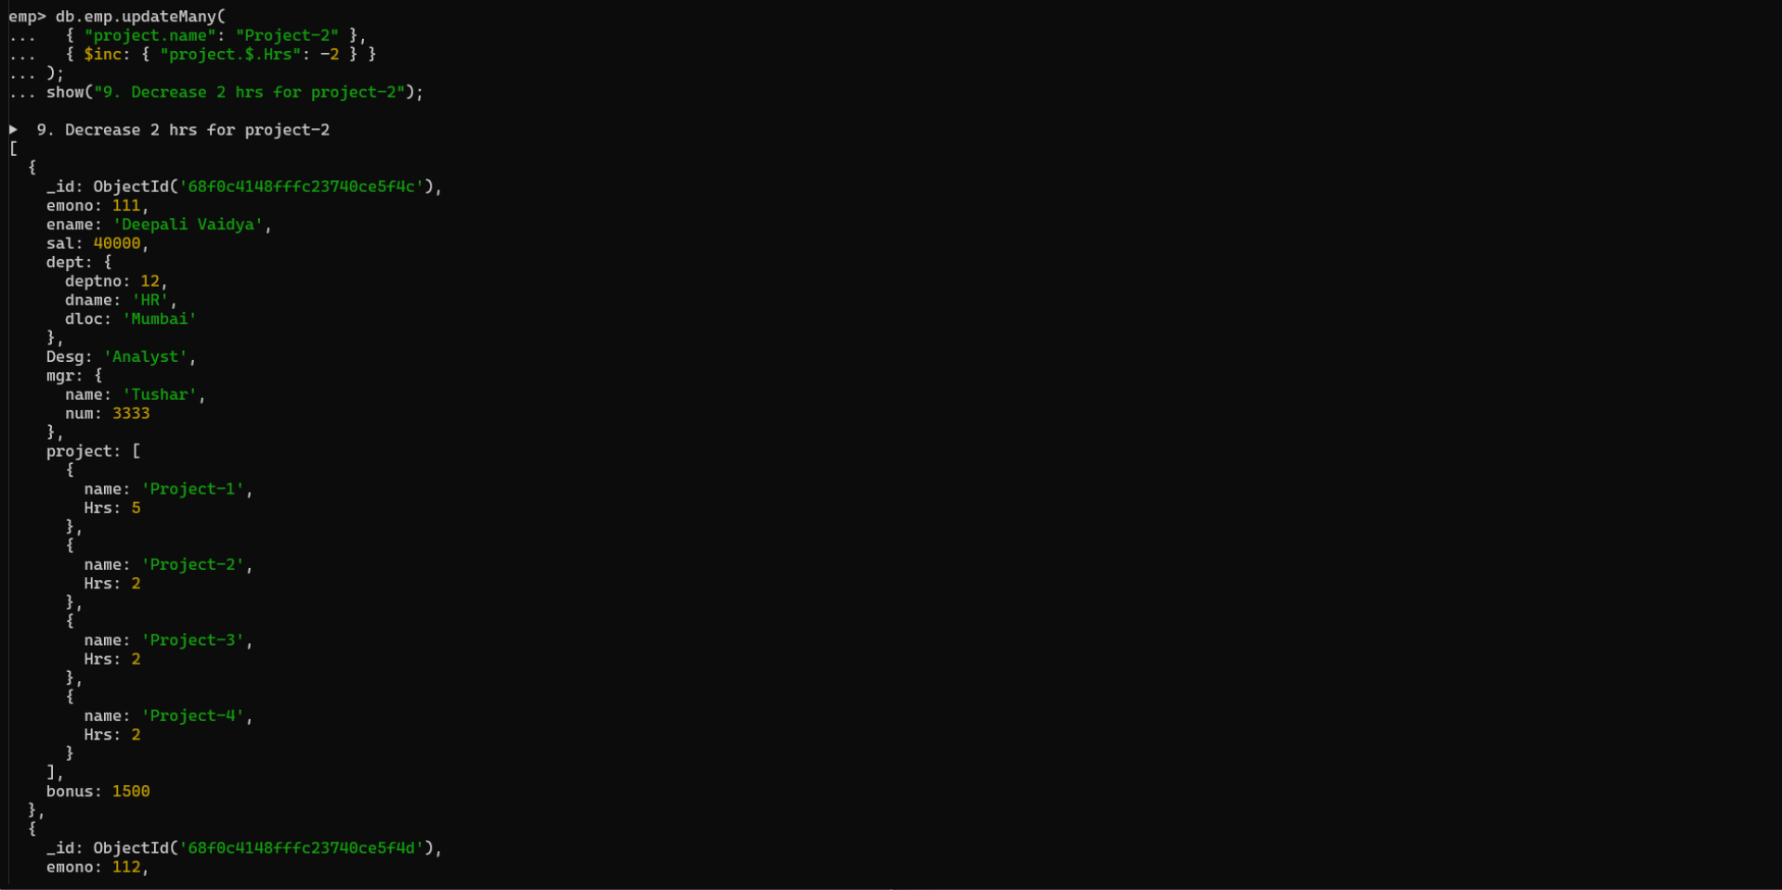

**10. Delete project-2 from all employee document if they are working on the project for 4**

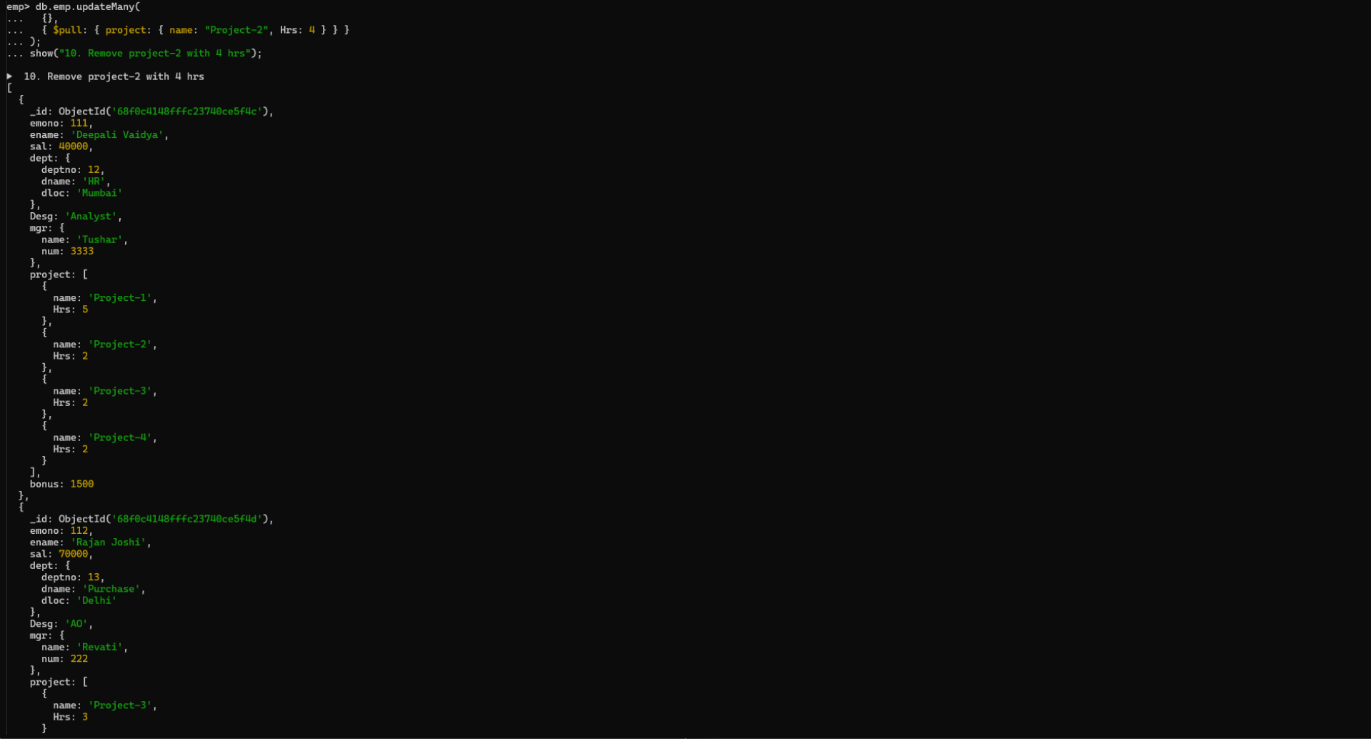

**11. Change the salary of employees to 10000 only if their salary is < 10000**

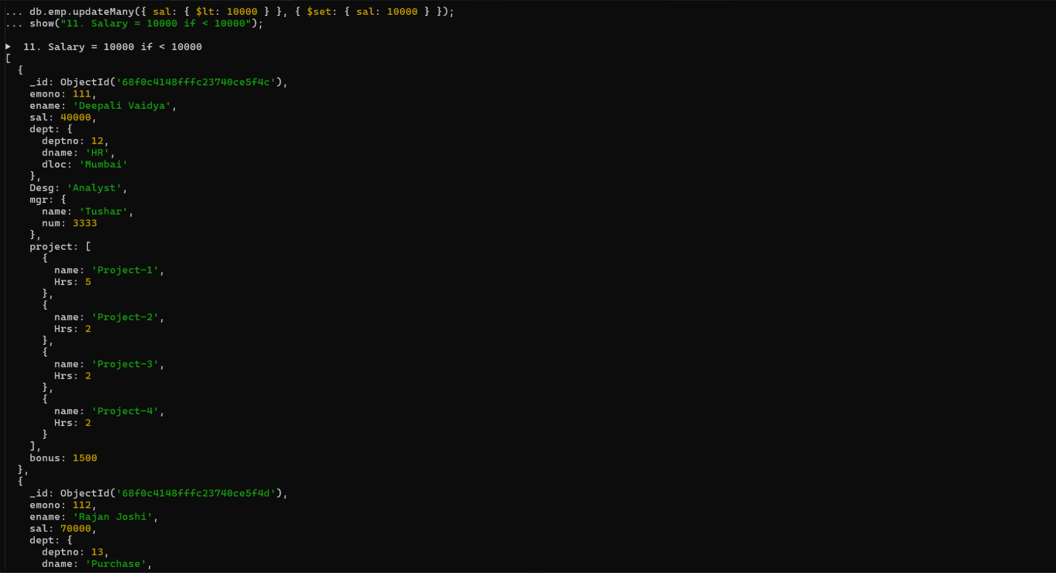

**12. Increase bonus of all employees by 500 if the bonus is <2000 or their salary is <**

**20000 or if employee belong to sales department**

**db.emp.updateMany(**

**{**

**$or: [**

**{ bonus: { $lt: 2000 } },**

**{ sal: { $lt: 20000 } },**

**{ "dept.dname": "Sales" }**

**]**

**},**

**{ $inc: { bonus: 500 } }**

**)**

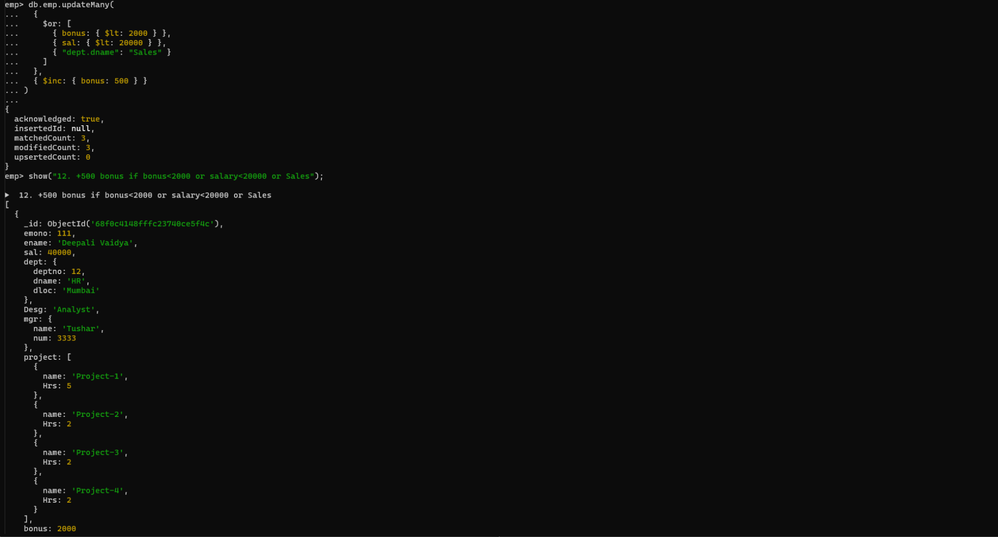

**13. Add 2 new project at position 2 for all employees with designation analyst or salary is**

**equal to either 30000 or 33000 or 35000**

**db.emp.updateMany(**

**{**

**$or: [**

**{ Desg: "Analyst" },**

**{ sal: { $in: [30000, 33000, 35000] } }**

**]**

**},**

**{**

**$push: {**

**project: {**

**$each: [**

**{ name: "Project-X", Hrs: 3 },**

**{ name: "Project-Y", Hrs: 3 }**

**],**

**$position: 1**

**}**

**}**

**}**

**)**

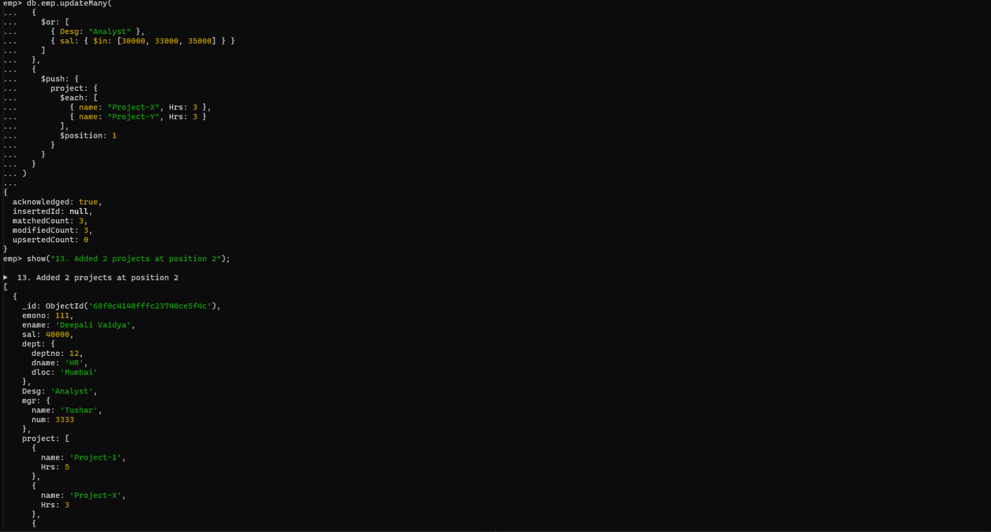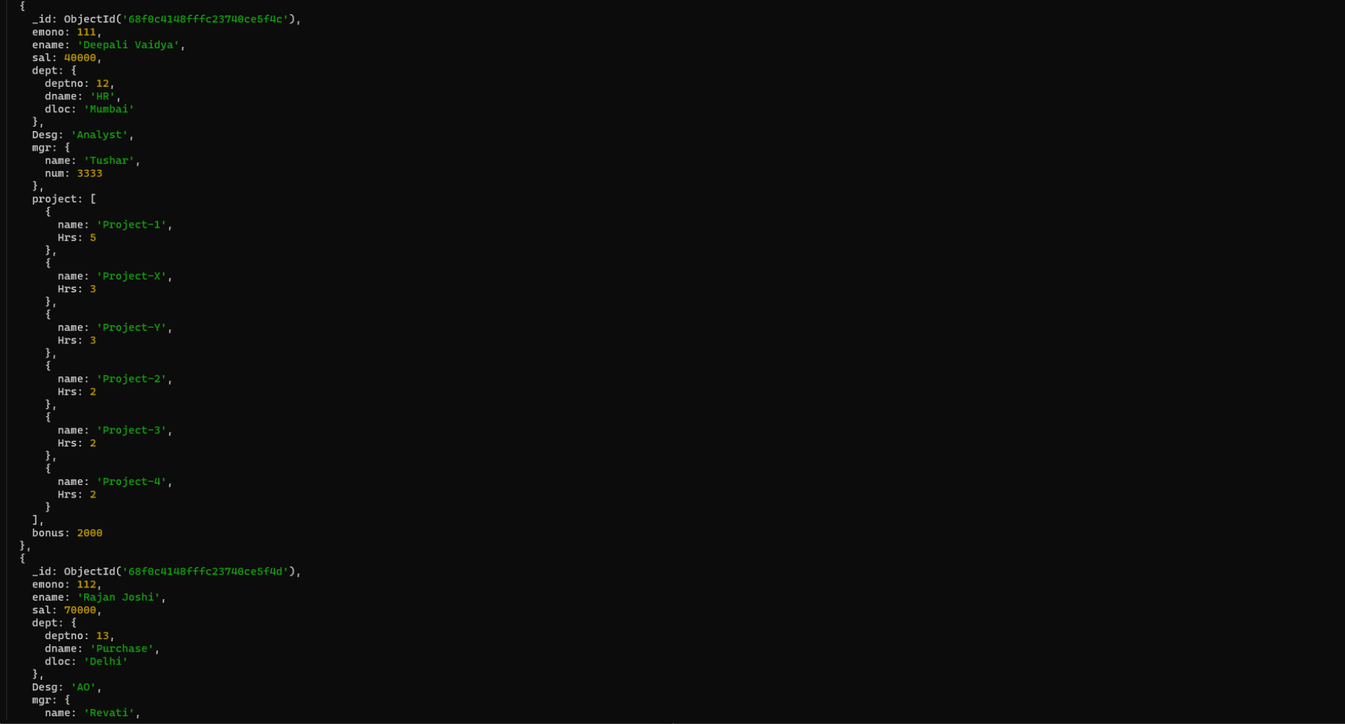

**14. Delete last project of all employees with department name is “HR” and if the location**

**is Mumbai**

**db.emp.updateMany(**

**{ "dept.dname": "HR", "dept.dloc": "Mumbai" },**

**{ $pop: { project: 1 } }**

**)**

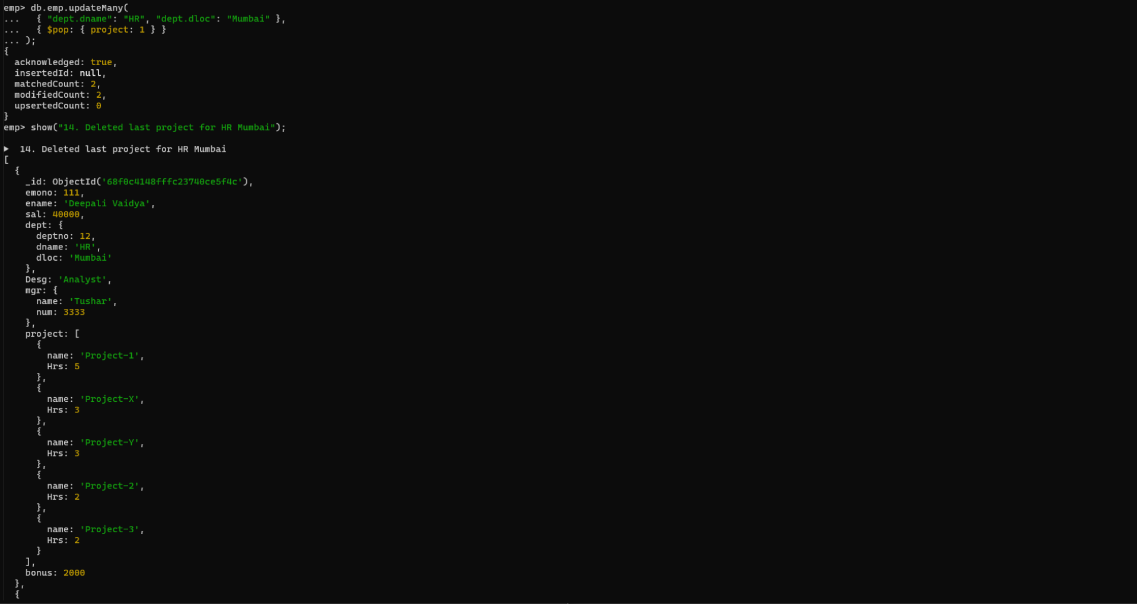

**15. Change designation of all employees to senior programmer if they are working on**

**name:”Project-1” for 4 hrs**

**db.emp.updateMany(**

**{ project: { $elemMatch: { name: "Project-1", Hrs: 4 } } },**

**{ $set: { Desg: "Senior Programmer" } }**

**)**

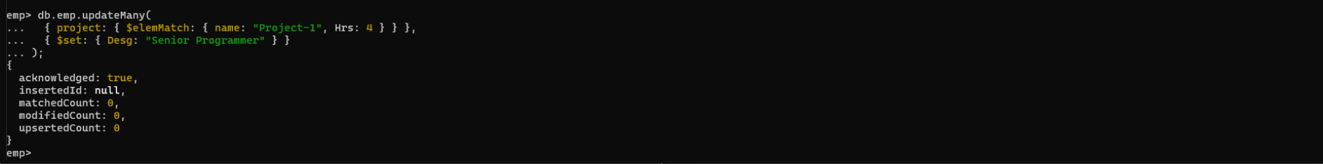

**16. Add list of hobbies in all employees document whose manager is Rajan or Revati**

**db.emp.updateMany(**

**{ "mgr.name": { $in: ["Rajan", "Revati"] } },**

**{ $set: { hobbies: ["Reading", "Travelling", "Music"] } }**

**)**

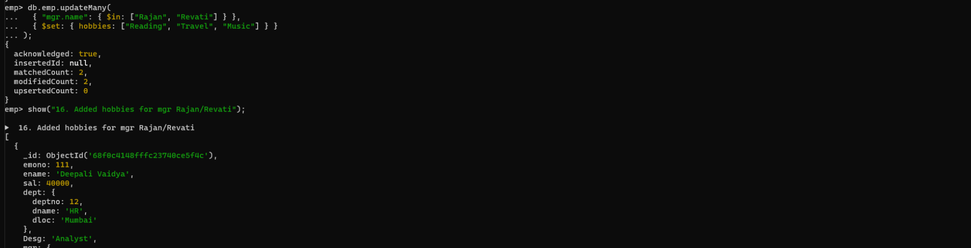

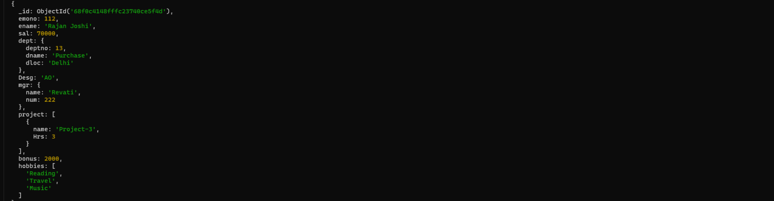

**17. Add list of skillset in all employee documents who are working on project-4 for 3 hrs**

**or on project-3 for 4 hrs**

**db.emp.updateMany(**

**{**

**$or: [**

**{ project: { $elemMatch: { name: "Project-4", Hrs: 3 } } },**

**{ project: { $elemMatch: { name: "Project-3", Hrs: 4 } } }**

**]**

**},**

**{ $set: { skillset: ["Python", "Java", "SQL"] } }**

**)**

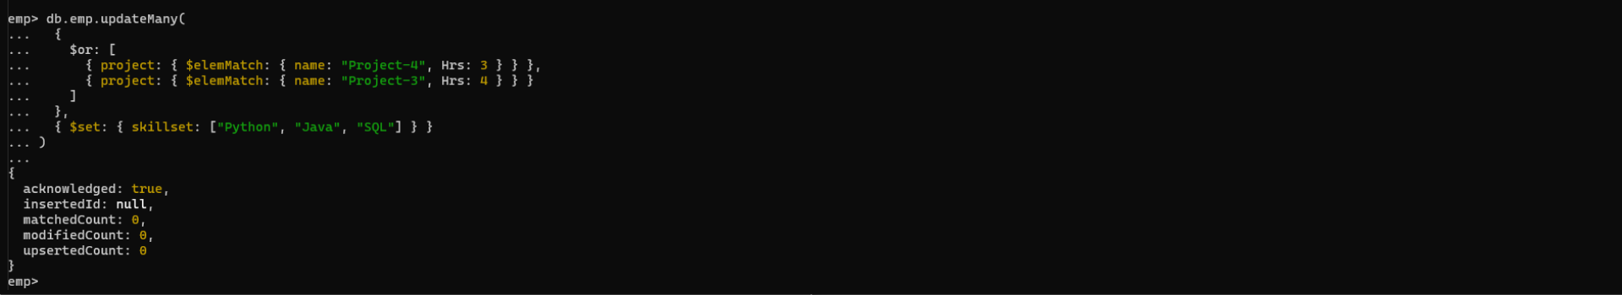

**18. Add a new hobby as blogging at 3 position in hobbies array for all employess whose**

**name starts with R or p and ends with j or s**

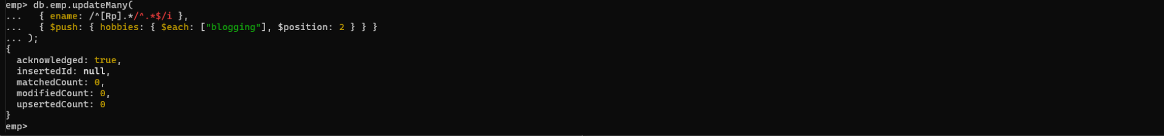

**19. Increase salary by 10000 for all employees who are working on project-2 or project-3**

**or project-1**

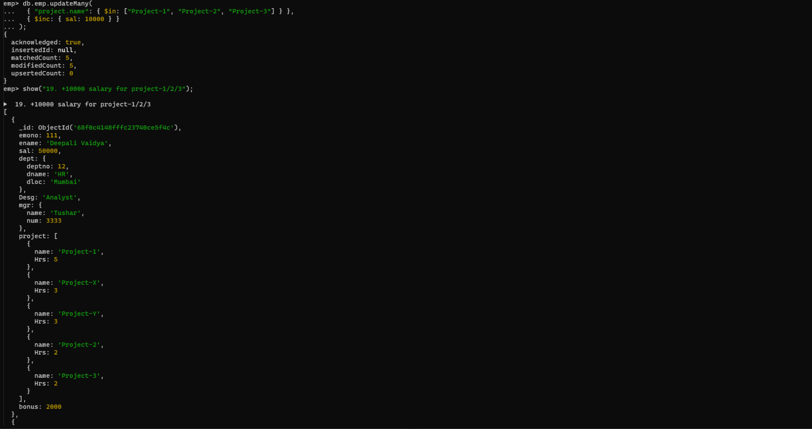

**20. Decrease bonus by 1000 rs And increase salary by 1000rs for all employees whose**

**department location is Mumbai**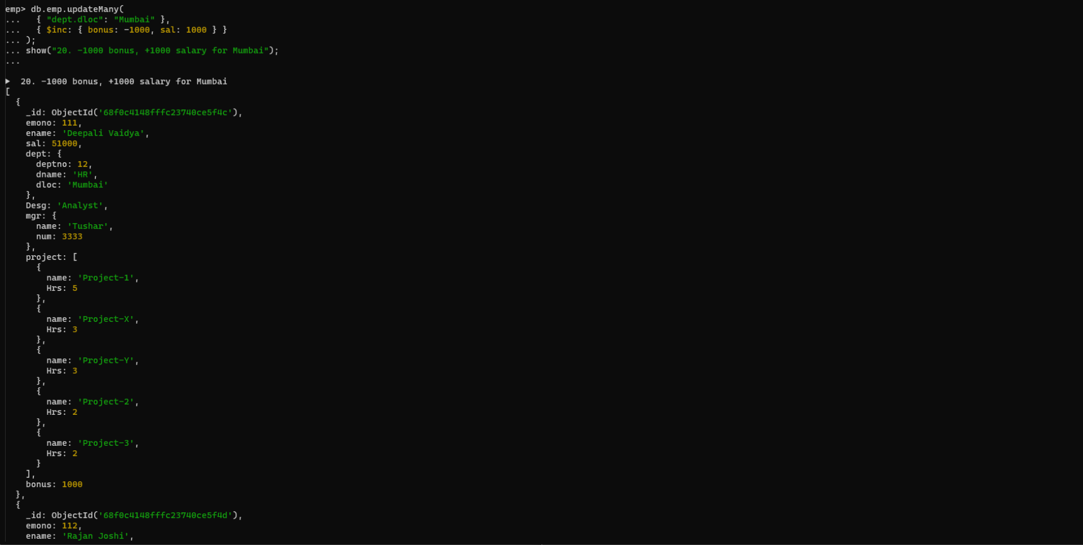

**21. Remove all employees working on project-1**

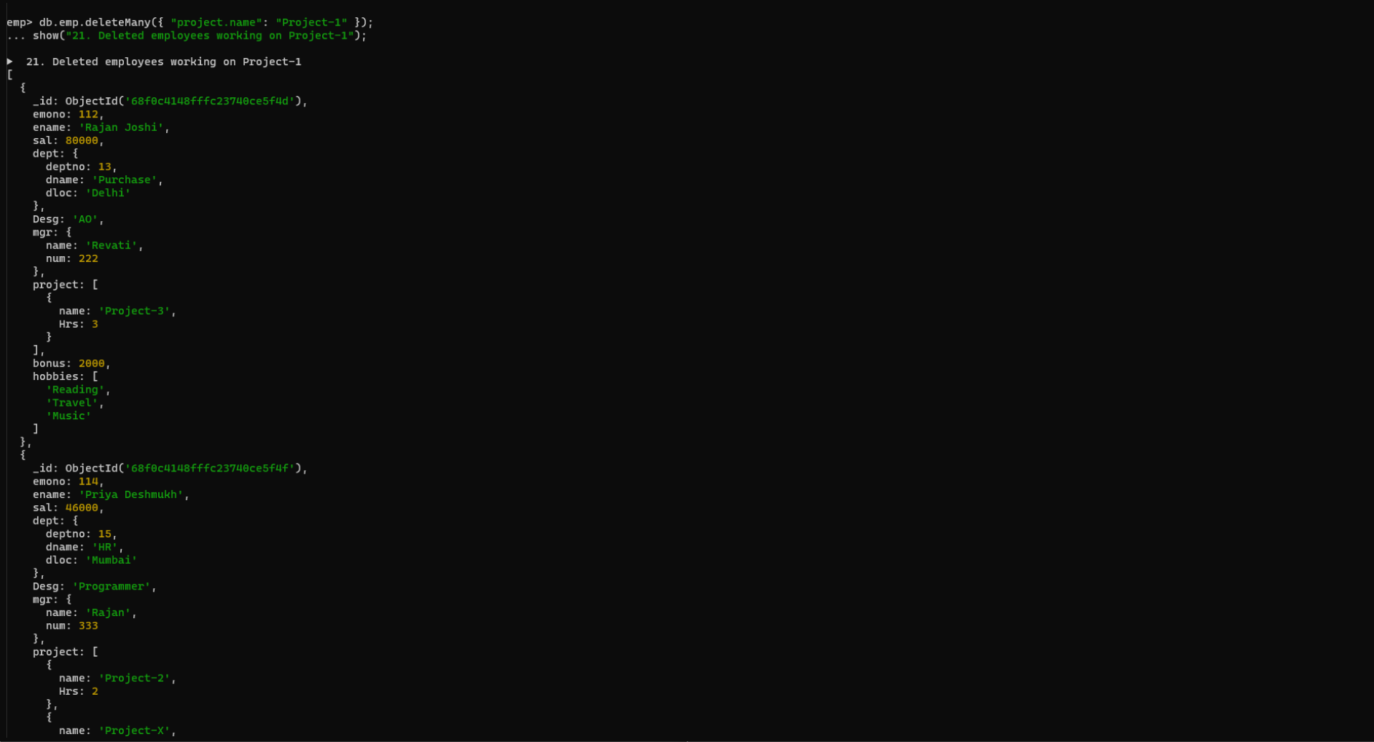

**22. Replace document of employee with name “Deepak to some new document**

**db.emp.replaceOne(**

**{ ename: "Deepak Pawar" },**

**{**

**emono: 200,**

**ename: "Deepak Desai",**

**sal: 50000,**

**dept: { deptno: 20, dname: "Finance", dloc: "Pune" },**

**Desg: "Developer",**

**mgr: { name: "Tushar", num: 3333 },**

**project: [{ name: "Project-New", Hrs: 5 }]**

**}**

**)**

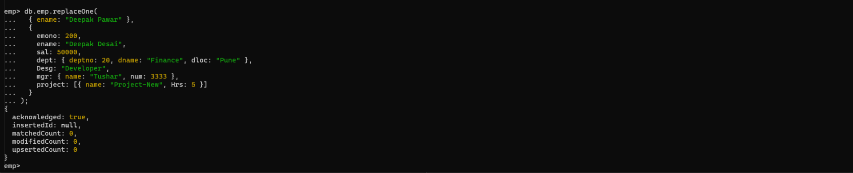

**23. Change skill python to python 3.8 for all employees if python is there in the skillset**

**db.emp.updateMany(**

**{ skillset: "Python" },**

**{ $set: { "skillset.$": "Python 3.8" } }**

**)**

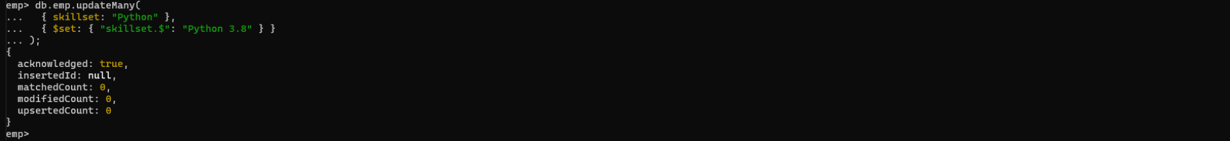

**24. Add 2 skills MongoDb and Perl at the end of skillset array for all employees who are**

**working at Pune location**

**db.emp.updateMany(**

**{ "dept.dloc": "Pune" },**

**{ $push: { skillset: { $each: ["MongoDB", "Perl"] } } }**

**)**

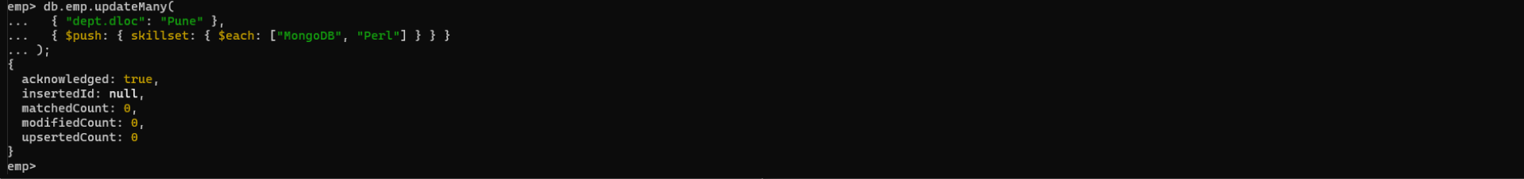

**Delete first hobby from hobby array for all employees who are working on project-1**

**or project-2**

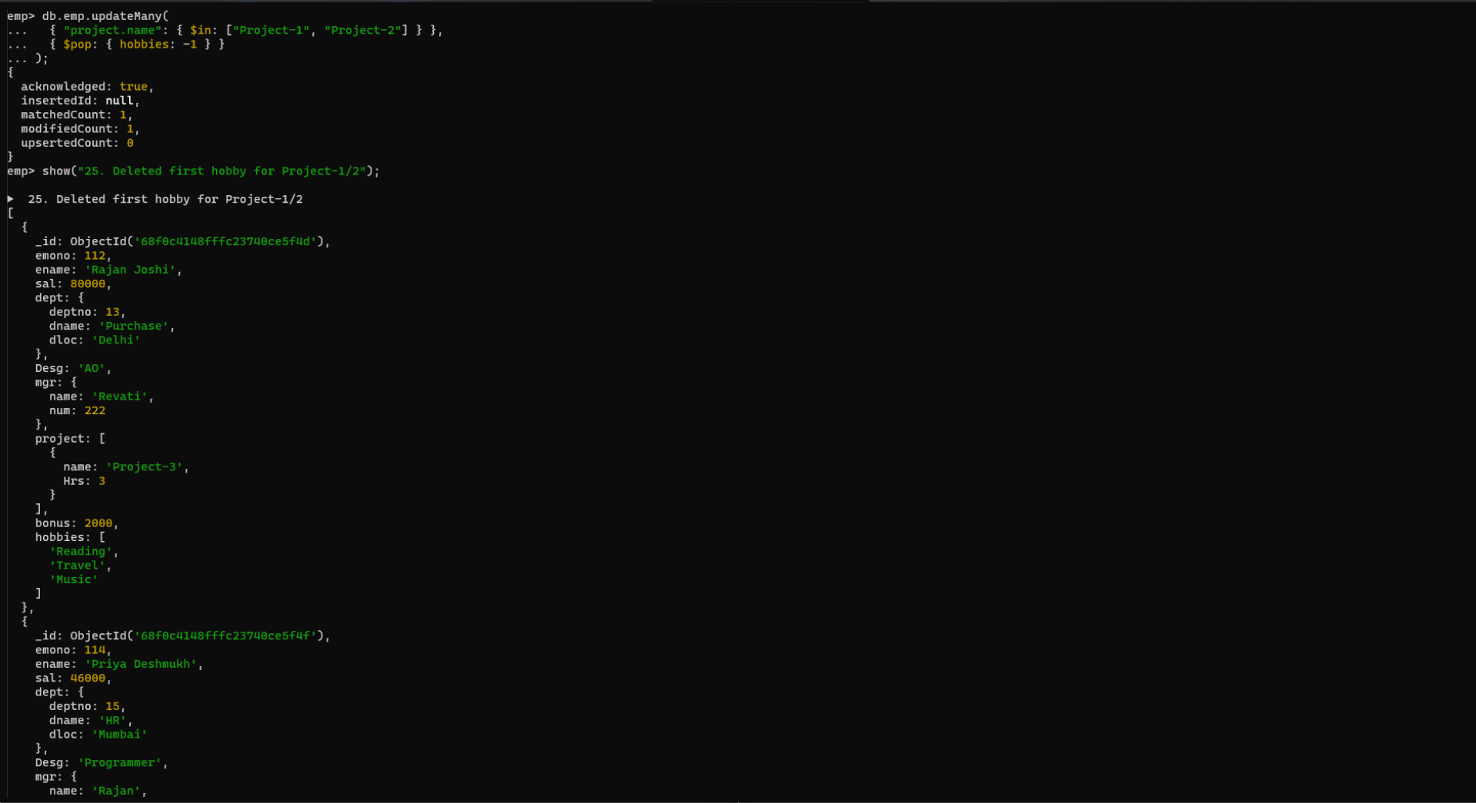

**Delete last hobby from hobbies array for all employees who are working on project**

**which is at 2 nd position in projects array for 4 hrs**

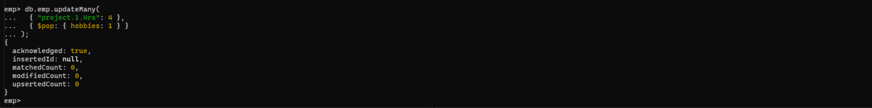

**Add 2 new projects at the end of array**

